Getting Started
An introductory guide for students

Aimed at students, this guide covers some of the basic functions of Panopto such as viewing recordings and uploading video.

Panopto

Table of Contents
1 Introduction 1
1.1 What is Panopto? 1
1.2 Logging In 1
2 Panopto Home Page Navigation 3
2.1 Shared with me 3
2.2 Search 3
2.3 Create 3
2.4 My Folder 4
2.5 Browse 4
3 Viewing Recordings 5
3.1 Via the Panopto Block in Moodle 5
3.2 Via a Link or Embed in Moodle 6
3.3 Access recordings directly in Panopto 8
4 Scheduled Lecture Capture 9
4.1 Are all of my lectures recorded? 10
4.2 When are lecture recordings available for me to view? 10
4.3 Why can’t I view my lecture recordings? 10
5 Watching a Recording 12
6 Adding Panopto recordings to assignments or portfolios 14
6.1 Creating Recordings 14
6.2 Editing recordings 15
6.3 Uploading recordings to an assignment folder 16
6.3.1 Upload a recording from your computer to the assignment folder in Panopto 16
6.3.2 Save a recording to the assignment folder using Panopto Desktop Recorder or Panopto Capture 18
6.4 Renaming recordings 20
6.5 Find the URL for a video in Panopto to link a recording to Moodle or Mahara 21
6.6 Embedding recordings 23

Introduction
As a student at the University of Bath, your first point of contact for any queries about how to use Panopto to support your studies should be directed to your course tutors. The tutors and wider course team are responsible for ensuring you have access to any recordings you need and will be advising you on how Panopto will be used on your specific course, as this may vary slightly between departments.

What is Panopto?
Panopto is the University of Bath’s video and audio platform. It allows staff to record lectures, upload their own recordings, and set video assignments for students.

Many Universities use similar systems for recordings. The company that provide the system is called Panopto and is widely used by universities.

Logging In
As a student, you will be able to log in to Panopto with your University of Bath username and password once you have fully completed registration and paid any fees that are due.

Panopto can be found at: https://uniofbath.cloud.panopto.eu

Upon navigating to this page, log in using your username and password.

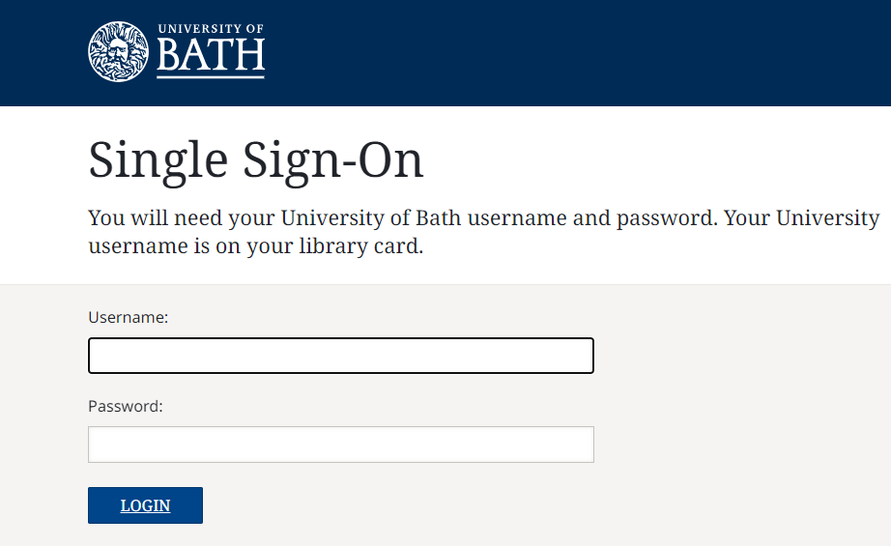

NB: If you are unable to log into Panopto, first check that you have completed registration fully. If there is still an issue, send a support request to the IT Service Desk.

Panopto Home Page Navigation
When you first log into Panopto, you should familiarise yourself with the following areas. To quickly return to the site Home page you can simply click on Home in the menu on the left-hand side.

Shared with me
The Panopto home page will display the latest recordings that have been shared with you. You can also click on Shared With Me in the menu to access all recordings that have been shared with you.

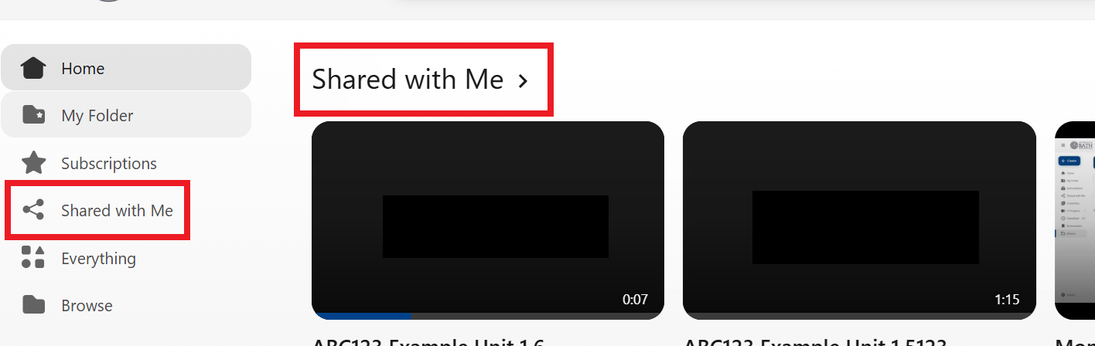

Search
The Search Bar at the top of the page allows you to search for recordings by name and content. For example, search for key words that have been used in the slides or voiceover.

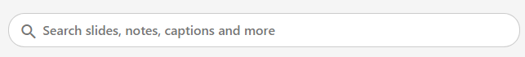

Create

The blue Create button gives you options for recording and uploading content. You may need to use this button if you are asked to produce a video or audio assignment.

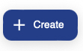

My Folder

My Folder is a private folder for your recordings. You could use this space to upload draft recordings when producing a video assignment.

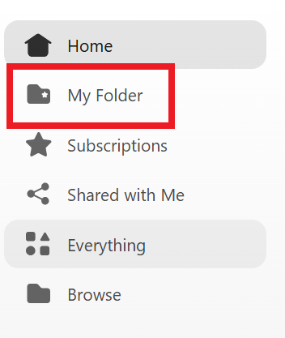

Browse

Browse allows you to look for recordings within their folders. Typically, each unit has a folder for your tutors to save recordings into each academic year. This folder is referred to as the Moodle-linked folder and has the same name as the corresponding Moodle space. The folder will be found in the Moodle folder for the current academic year. For example, in the academic year 2026-2027, the Moodle linked folder will be found in the Moodle AY2627 folder.

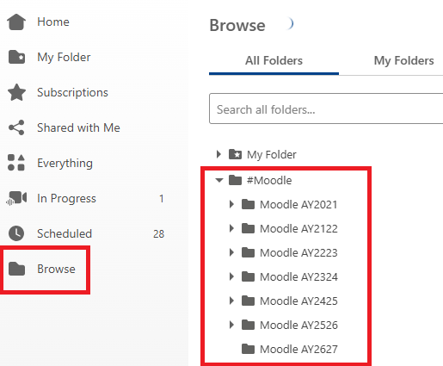

Viewing Recordings
Each department uses Panopto in a slightly different way to support your studies, depending on the nature of the subject matter. Below are the most common ways to access recordings in Panopto.

Via the Panopto Block in Moodle
Located within the Block Drawer on the right-hand side of each Moodle space, the Panopto block displays the most recent recordings from the Moodle-linked folder. Students can click on the title of these recordings and will be prompted to log into Panopto to watch them.

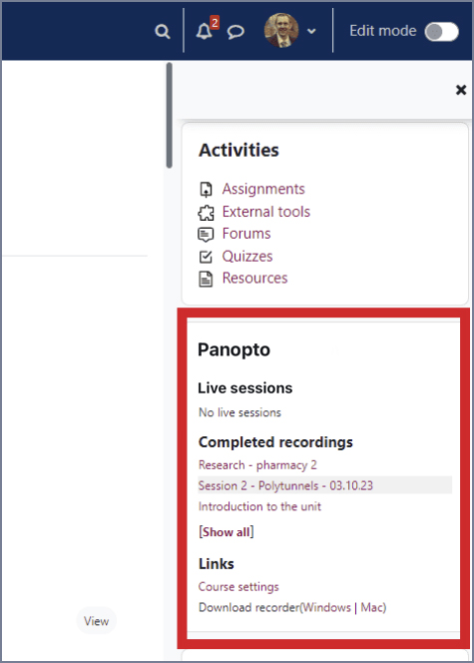

Via a Link or Embed in Moodle
Many staff link and/or embed recordings in Moodle to scaffold students’ learning throughout a unit.

Recordings can be embedded into Moodle activities such as pages, books, and text and media areas to enable students to watch videos without leaving the Moodle platform. Links to recordings can be added in a similar way and will open directly in Panopto.

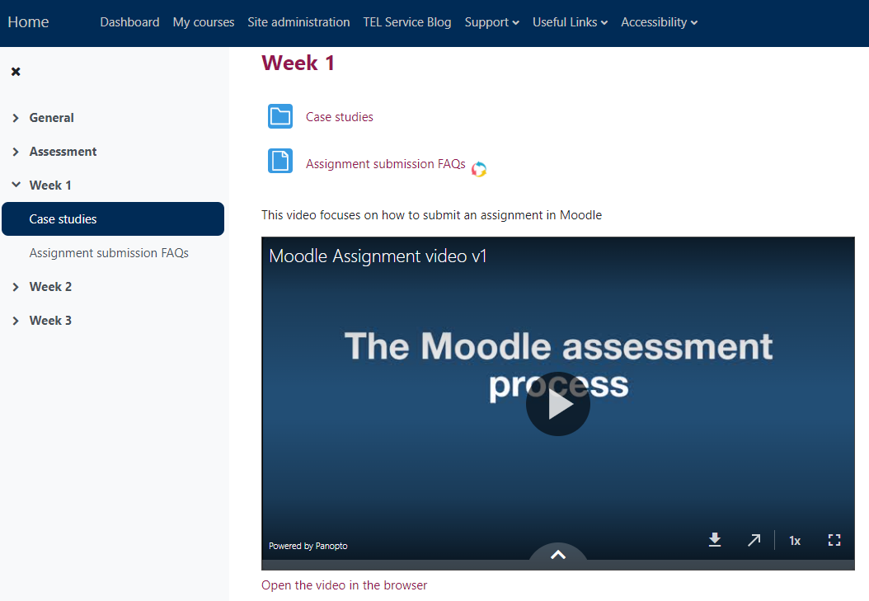

In some browsers, due to privacy settings, you may see a ‘Click to sign in and play video option’ when viewing an embedded recording. Click this and Panopto will automatically log you in to view the recording.

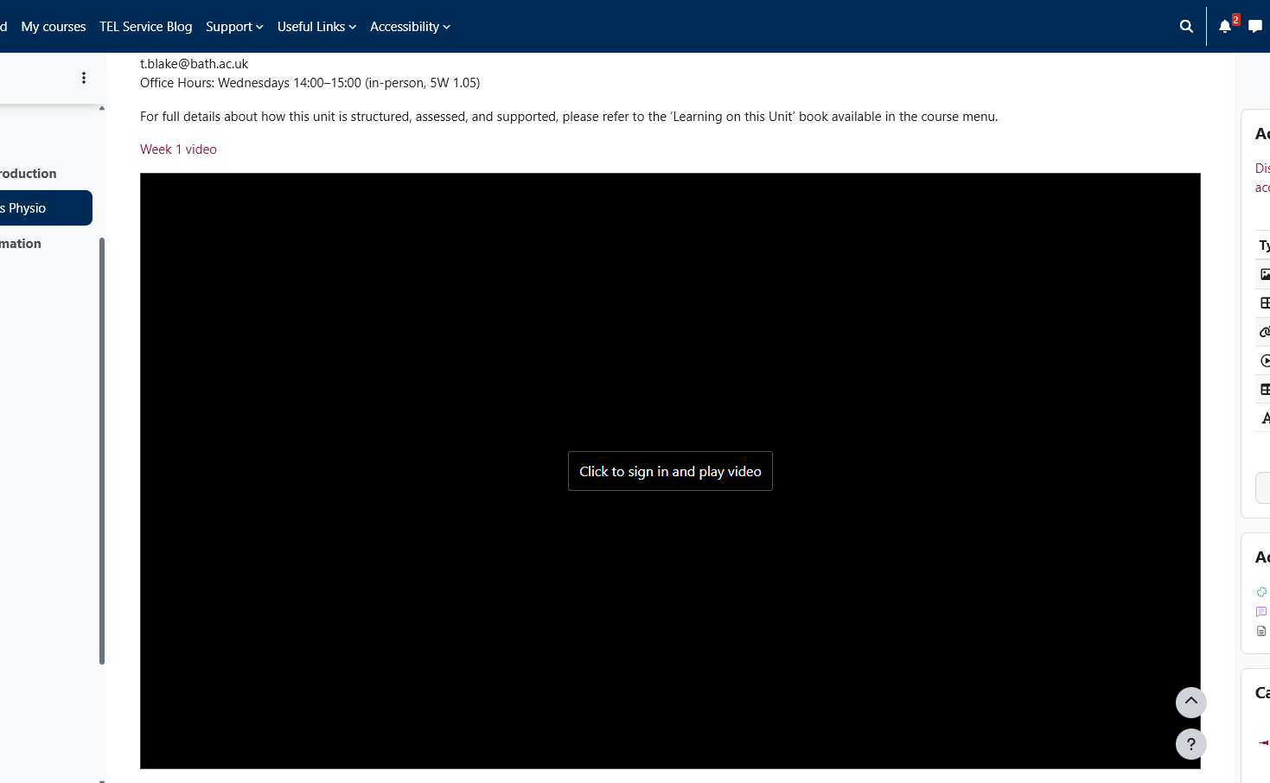

Access recordings directly in Panopto

You can log into Panopto directly and access the latest videos that have been shared with you. The most recent will appear first. As well as their course-related recordings, you will also be able to view recordings that have been made available to everyone at Bath.

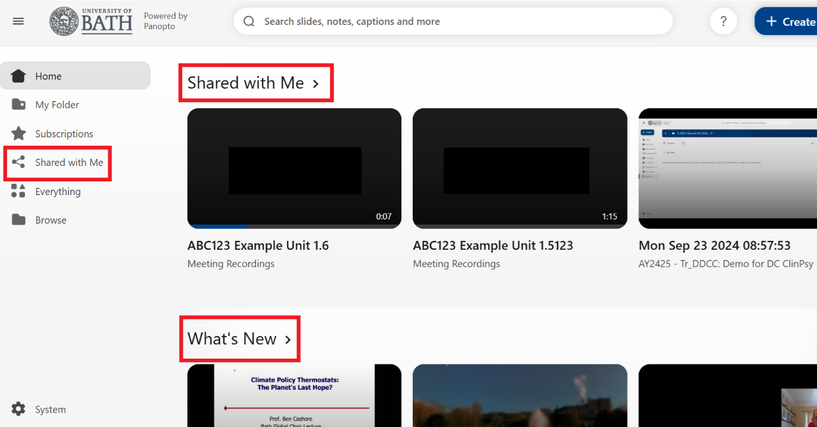

You can log into Panopto directly and browse folders of recordings from current and previous academic years (assuming you have viewing permissions). You can also use the search functionality to search for recordings by key word.

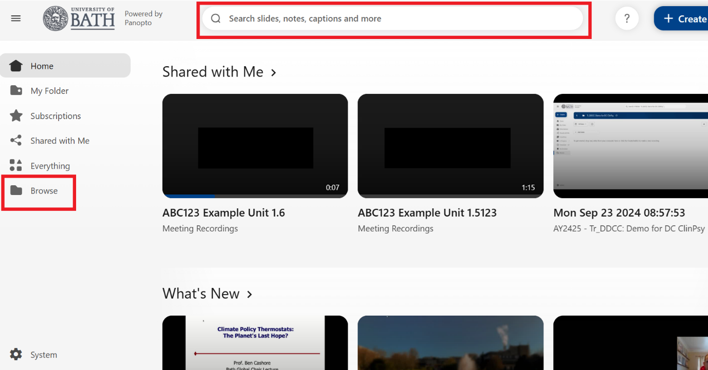

Scheduled Lecture Capture
Panopto can be used by your tutors to automatically record teaching sessions on campus. Below are some of the frequently asked questions about this process.

Are all of my lectures recorded?

The University of Bath operates an ‘opt-in’ lecture recording policy – this means that staff can choose whether to record their taught sessions.

Some teaching sessions (e.g. labs, discussion sessions, or sessions where confidential or sensitive information is relayed) may be inappropriate for recording, and the judgement is given to the member of staff delivering the session as to whether it should be recorded or not.

Lecture capture is intended to supplement your learning and should not be considered as a replacement for attending a session.

When are lecture recordings available for me to view?

By default a scheduled lecture will not be viewable to you until 24 hours after the recording takes place. This is to give staff time to edit the recording before it is released to students. Editing may include cutting out sections of sensitive discussion, removing copyrighted content, or there may be students who do not wish to be recorded. Staff may also wish to edit the recording to cut out anything that does not add value to the learning, e.g. long pauses, technical errors or breaks.

Why can’t I view my lecture recordings?

There may be several reasons:
- The lecture has not been scheduled to be recorded by the tutor.
- The recording appears 24 hours after the lecture takes place to allow time for staff to edit it - you may be trying to view it before it has been released.
- Your tutor may have manually set the lecture to release at a different time or date - perhaps to allow them time to edit the recording.

Watching a Recording

When watching a recording, you can take advantage of functionality in Panopto to enhance the viewing experience.

The menu on the left-hand side allows you to perform actions such as:
- Search for key words within the recording.
- Navigate via contents.
- View captions.
- Create your own private notes and bookmarks.

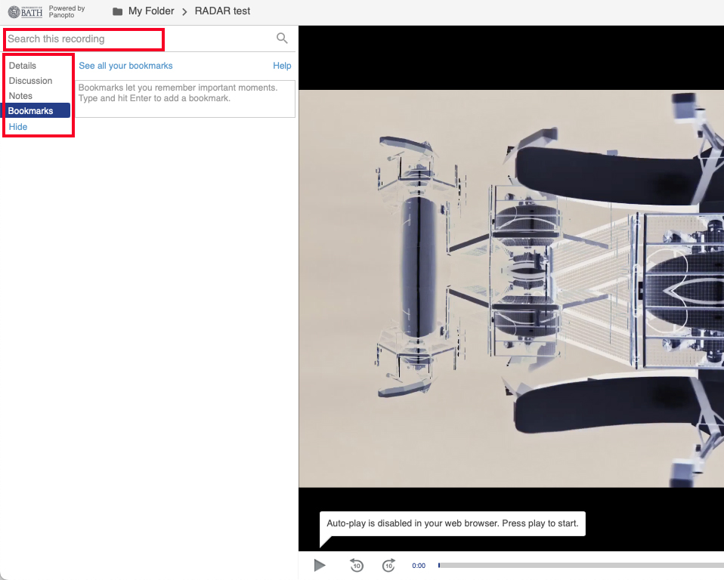

In the main viewing area you can:
- Play and pause the recording.
- Adjust the playback speed and quality.
- Adjust the volume.
- Turn on/off captions.
- Resize and reorder screens.

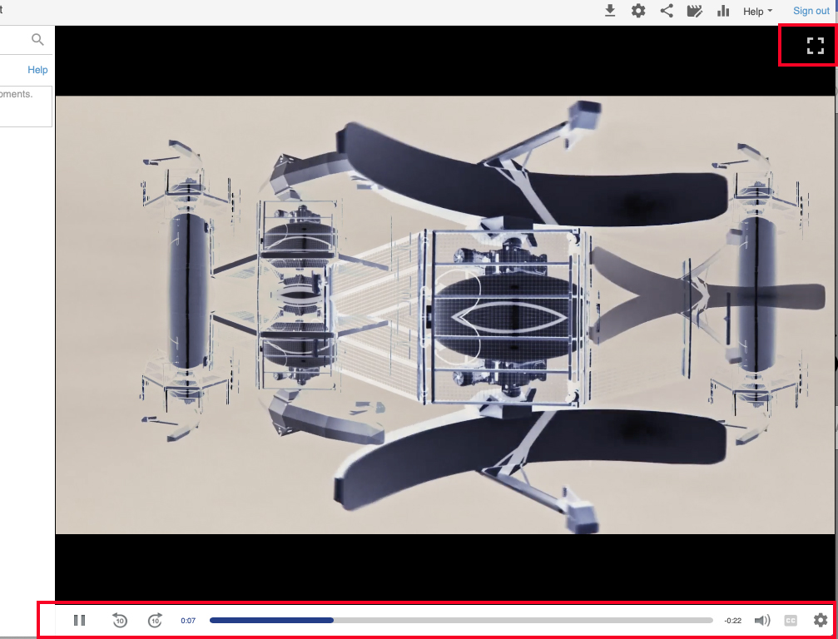

Adding Panopto recordings to assignments or portfolios

Both Moodle and Mahara have a maximum file size limit of 50MB which would rule out all but the shortest of media recordings. The solution is to place recordings in Panopto and share the links or embed the recordings in Moodle or Mahara.
The assignment folder in Panopto allows students to upload videos to a folder – as part of an assignment or instead of a face-to-face presentation. Assignment Folders enable you to create and manage your own content whilst preventing you from viewing other users’ content that has not been explicitly shared or made public. Anything you upload to an assignment folder cannot be viewed by other students unless a staff member enables this.

Creating Recordings
There are many ways to create recordings, whether it be on a mobile device, a laptop, or digital camera. Three methods include:

Create narrated PowerPoint presentation
The simplest way of recording a presentation is to create a voiceover/insert video into an existing Powerpoint. All students at Bath have access to PowerPoint through their Microsoft 365 subscription.

To create the video you need to then export your presentations as an .mp4 video file and upload your video to the Panopto Assignment Folder.

Use Panopto Desktop Recorder or Panopto Capture
Video capture can be made using the Panopto Desktop Recorder or Panopto Capture. Panopto Desktop Recorder can be downloaded to your device, whereas Panopto Capture can be used in a browser without downloading anything. Users can record various inputs simultaneously, such as video from a webcam, audio, PowerPoint and/or screen capture.

Further guidance can be obtained from Panopto’s help pages.

Install Panopto Desktop Recorder for Windows.
Install Panopto Desktop Recorder for Mac.
How to record with Panopto Desktop Recorder for Windows.
How to record with Panopto Desktop Recorder for Mac.
How to record with Panopto Capture using Chrome, Firefox, and Edge browsers.
How to record with Panopto Capture for the Safari browser.

Clipchamp is a simple online video editor included as part of the Microsoft Office 365 licence and is available to all staff and students at the University. It allows users to record and edit their presentations. It also offers users a script feature which overlays a scrolling script over their presentation, this helps to reduce hesitation or errors in the delivery. Recordings can be edited in Clipchamp and downloaded to the user’s device and uploaded to Panopto. All students at Bath have access to Clipchamp through their Microsoft 365 subscription. You can log into Clipchamp using a work account, which is your University of Bath email address and password.

Editing recordings
Panopto offers basic editing functionality such as being able to rename recordings, add captions, and snip sections of video.

How to edit a recording in Panopto.

You may wish to edit your recording before uploading it to Panopto. It is impossible to list all the available video editing software for different devices. Clipchamp is a simple online video editor included with Microsoft 365 and is available to all staff and students at the University. Clipchamp is accessed via Edge and offers a few advanced features such as transitions which are not available in Panopto. Of course, you may have access to your own video editing software that you are familiar with.

Uploading recordings to an assignment folder

The Assignment Folder is located within the Moodle-linked folder for your unit. It has the same name as the Moodle-linked folder but with [assignments] added to the end.

You may need to hover over the name of the folder for [assignments] to appear.

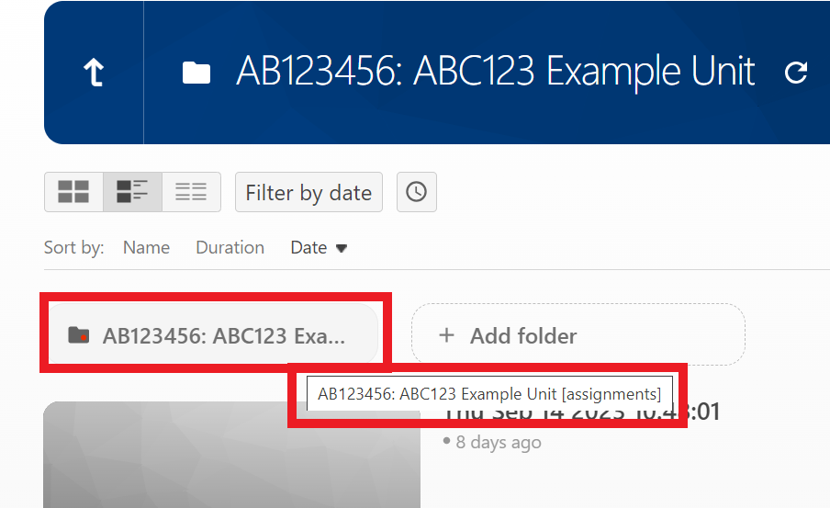

For your recording to be visible to your tutors, you must ensure it is saved in the Assignment Folder. Before uploading the recording, save it in a suitable video or audio format, such as an .mp4 file.

Upload a recording from your computer to the assignment folder in Panopto

- Log in to Panopto at https://uniofbath.cloud.panopto.eu with your Bath username and password.
- Click Browse.
- Click on #Moodle.
- Click on the Moodle AY folder for the current academic year for example for the academic year 2026 to 2027 the Moodle folder will be named Moodle AY2627
- Click on the unit title.
- Click on the unit title labelled [assignments]. You may need to hover your mouse to make the entire folder name appear.

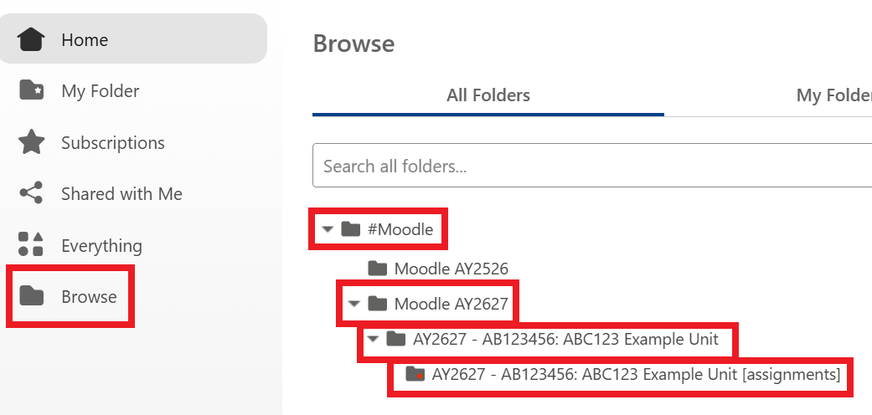

Once you have opened the folder with [assignments] at the end, click on the blue Create button.

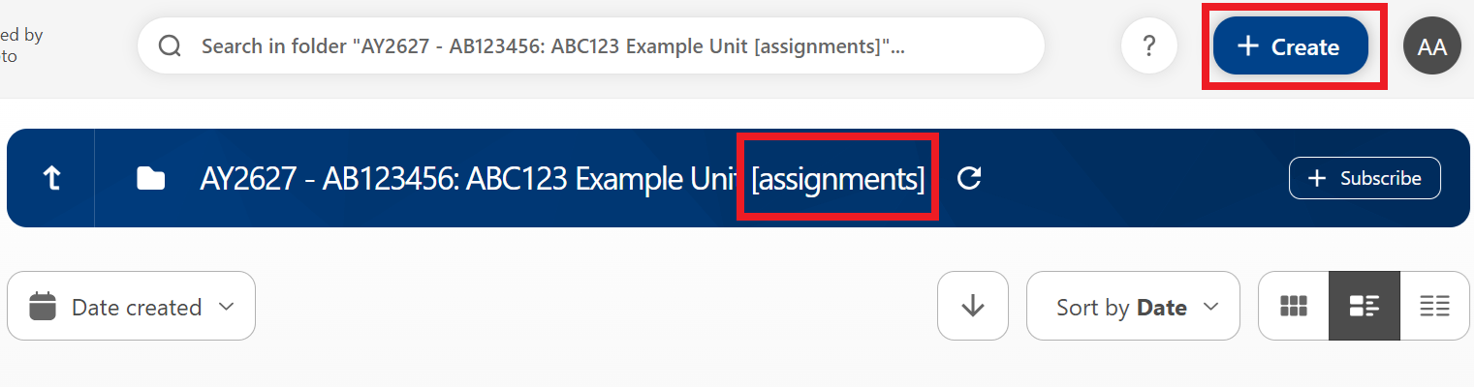

Select Upload Media.

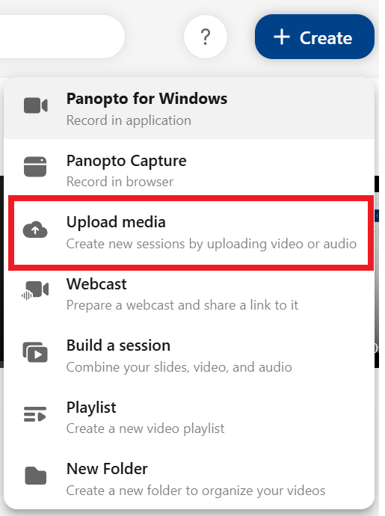

You will then see the option to upload the recording from your computer. This could take some time depending on your internet connection. You will only be able to see your own files and the tutors on the unit will be able to see all student files.

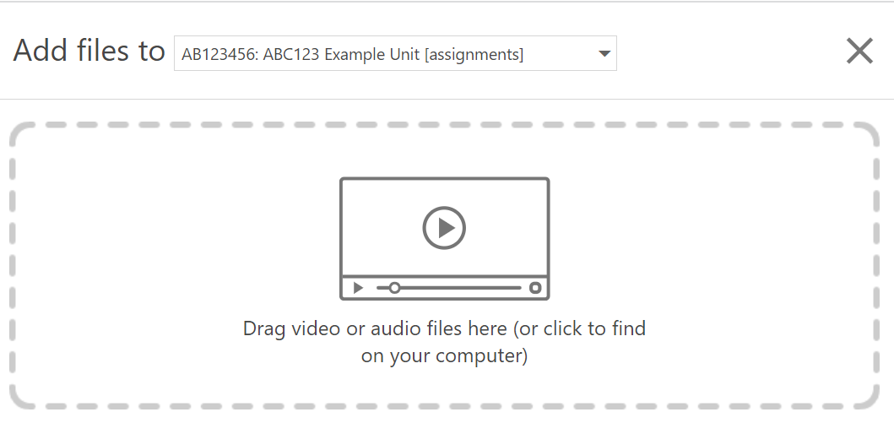

Save a recording to the assignment folder using Panopto Desktop Recorder or Panopto Capture

It is possible to record a video and include PowerPoint directly into Panopto using the Panopto Desktop Recorder or Panopto Capture.

It is important that you create the new recording in the correct folder.

In Panopto Desktop Recorder, before you record use the dropdown menu to navigate to the folder for where you want to save the recording. Make sure that you place the recording in the correct Moodle Linked folder for the current academic year. For example, Moodle AY2627 for the academic year 2026 to 2027.

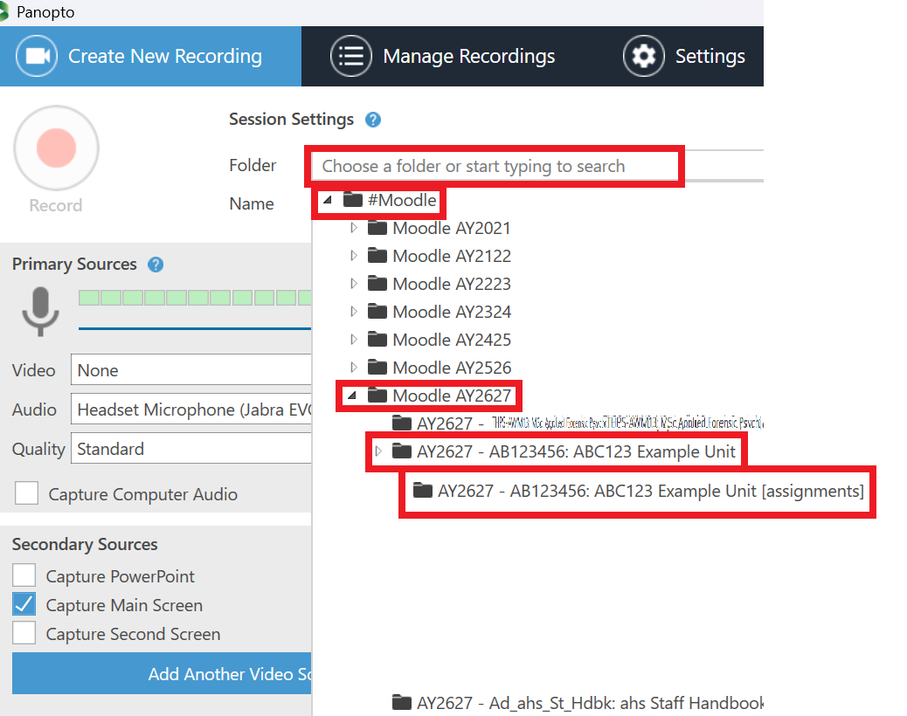

In Panopto Capture, you can choose the destination folder after you have made the recording.

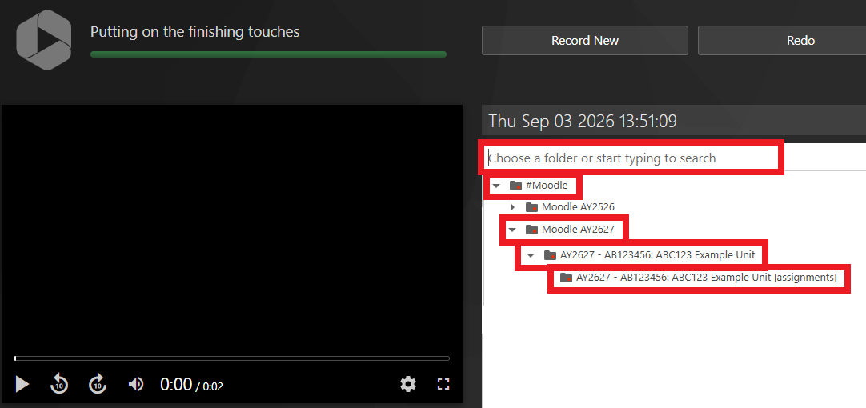

The default is usually set to moodle\username or unified\username. If you do not change the destination folder then it will be saved into your private My Folder and only you will have access to it. You may wish to do this and move the recording later if it is a practise or first attempt. However, if you wish to record directly into the assignment folder then you can change the destination folder to the folder you have been directed to as part of the assignment upload process by your tutor.

It is also possible to rename the recording. If you do not do it at this stage then the recording will be named with the date and time, e.g. ’06 April 2025 at 13:20:12′.

Note: If you encounter issues with animations not working in a recorded PowerPoint, we suggest that you select ‘Capture main screen’ and capture the PowerPoint that way.

Renaming recordings

It is possible to rename your video by hovering over the recording and selecting the Settings cog. The names of recordings are limited to a maximum length of 199 characters, files with names exceeding this limit will not be uploaded successfully or saved.

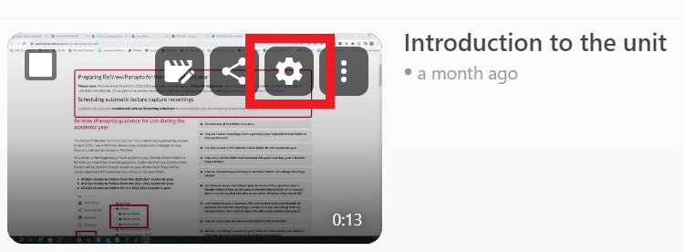

Click on Edit, type in a suitable name and click Save.

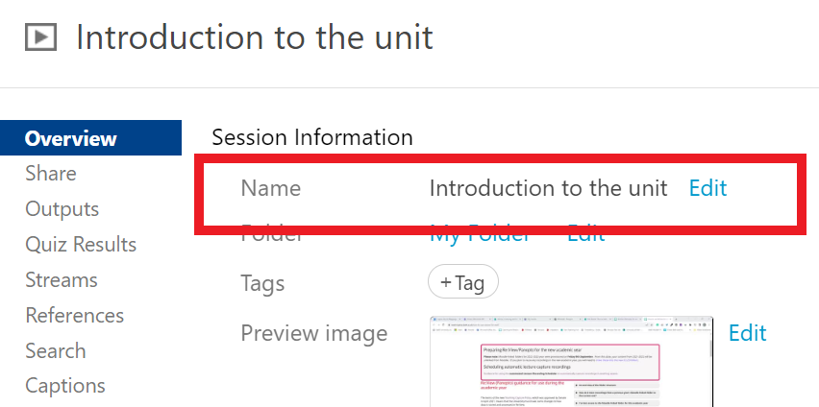

Your tutors may have given you specific guidance about how to name your video. It could include your name, the name of your assignment, group name, or date. Please check with your tutor if your video should follow a specific naming convention.

Find the URL for a video in Panopto to link a recording to Moodle or Mahara
If you need to share the link to a recording, then you can do so by hovering over the recording and clicking on the Share button.
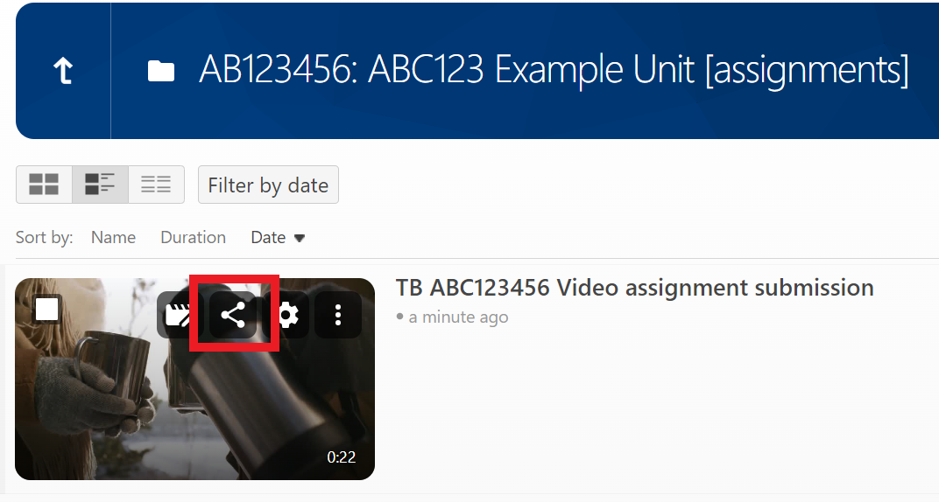

Here you will find a URL that you can copy and paste elsewhere (for example into a Moodle assignment, document or email).

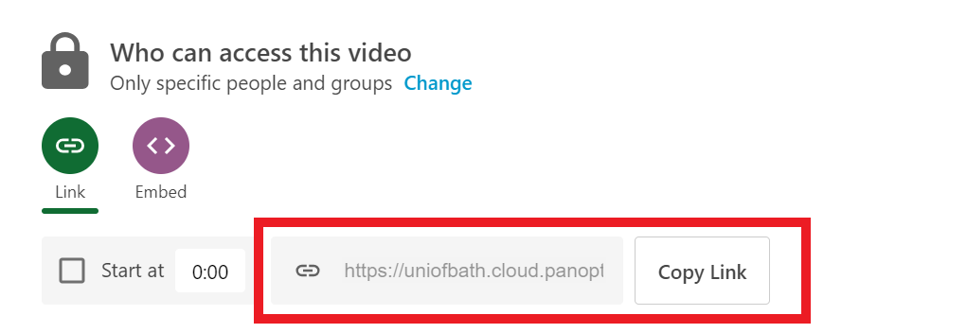

Permissions for the recording are shared with the parent folder. This means that your recording will not be viewable by anyone with the link, just by those who have owner permissions in the associated course folder (likely to be the tutors on your unit).

If you share the link to a recording which is saved in your private My Folder then your tutors will not be able to view it.

Embedding recordings
Recordings can also be added to Moodle spaces or Mahara portfolios using the embed option. An embedded recording can be used to break up blocks of text and provide a more pleasing experience than a simple URL.
If you want to embed a recording, move your cursor over the recording and click on share.
Click on the Embed button and then click on Copy Embed Code.
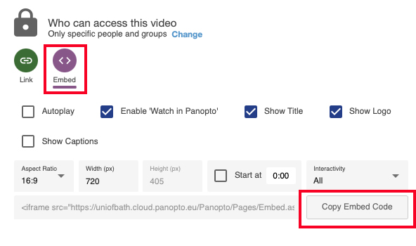

Open your Mahara portfolio and add a Text block. At the top left of the text editor, toggle the toolbar to show the full list of buttons. Switch to html view using the Source code button, paste the Embed code into the text editor.
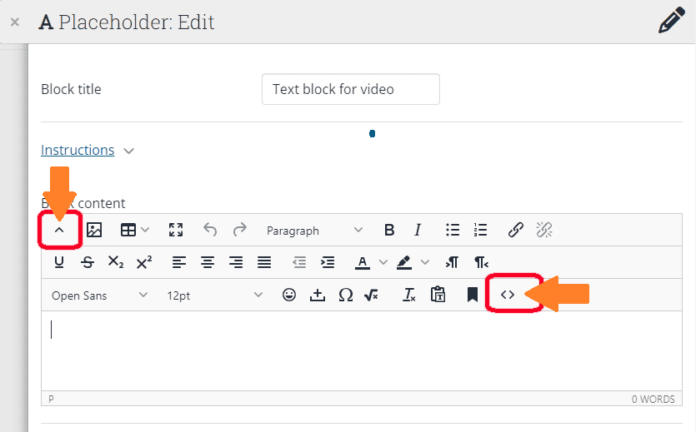
Save to display a preview of the embedded video and Save the Text block to display it on the portfolio page.

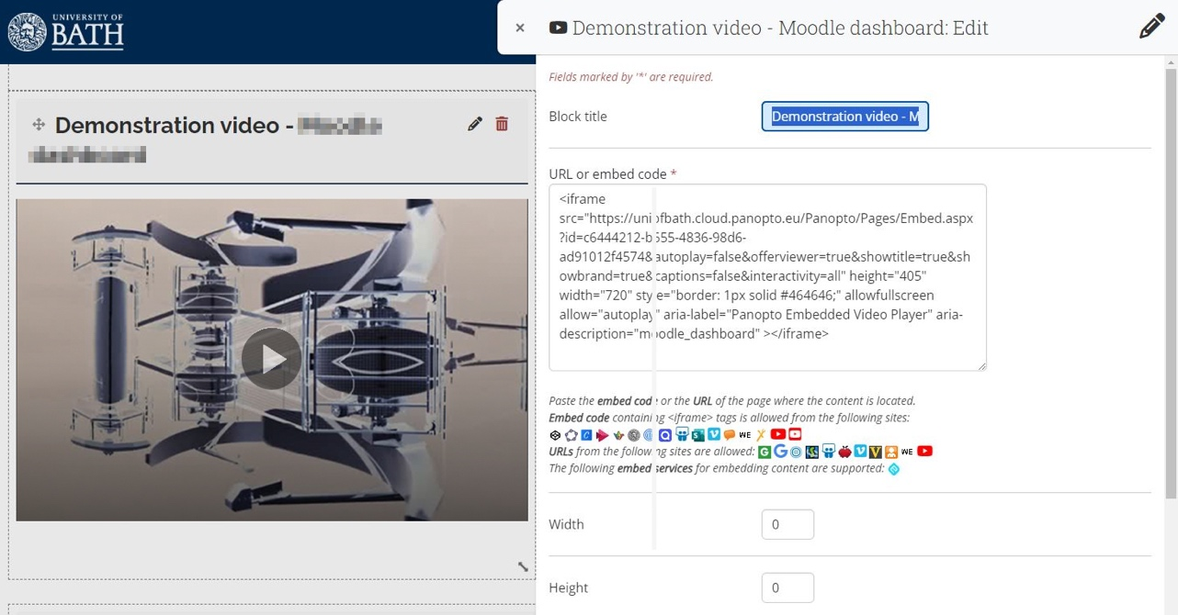


This work is licensed under a Creative Commons Attribution-ShareAlike 3.0 Unported License.
Updated: September 2026

