TEL Team, University of Bath

Aimed at students, this guide covers some of the basic functions such as navigating Moodle and uploading assessments.

Getting Started with Moodle 4.5

An introductory guide for students

**Table of Contents**

Contents

1 Introduction 2

1.1 What is Moodle? 2

1.2 Logging In 2

1.3 User Profile 3

1.4 Site Layout 4

1.4.1 The Course Index 6

1.4.2 Course tool bar 6

2 Navigation 8

2.1 Using the Content Area 8

2.2 Using the Course Index 8

3 Content Delivery 10

4 Assessments 10

4.1 Uploading an assignment 10

4.2 Submitting a Quiz 11

5 Alternative formats 13

5.1 Downloading a resource in an alternative format 13

6 Contact and support 13

7. Appendix 15

7.1 Summary of key icons and functions 15

# Introduction

As a student at the University of Bath, your first point of contact for any queries about how to use Moodle to support your studies should be directed to your course tutors or departmental administrative teams. The tutors and wider course team are responsible for ensuring you have access to any units you need and will be advising you on how Moodle will be used on your specific course, as this may vary slightly between departments.

## What is Moodle?

Moodle is a Virtual Learning Environment (VLE). It is essentially a website that facilitates the delivery of content and activities to you through the provision of a range of built in tools and functions.

Moodle can be used to deliver anything from a wholly online course to one that supports aspects of traditional, face-to-face interaction (blended learning).

Whilst Moodle is commonly used to provide access to content, it can also facilitate and support a more active approach to learning through the use of forums, wikis, quizzes, etc.

## Logging In

As a student, you will be able to log in to Moodle with your University of Bath username and password once you have fully completed registration and paid any fees that are due.

Moodle can be found at: [https://moodle.bath.ac.uk](https://moodle.bath.ac.uk/)

Upon navigating to this page, click on the link to Log in (top right) and you will be prompted for your username and password.



**NB:** If you are unable to log into Moodle, first check that you have completed registration fully. If there is still an issue, send a support request to the IT Service Desk for them to check your account. (<https://bath.topdesk.net/tas/public>)

## User Profile

When logged into Moodle you will be able to view your Moodle profile by clicking on your profile icon at the top right of the page.



You may want to edit your profile information and account preferences. You can do this by choosing the **Preferences** option.

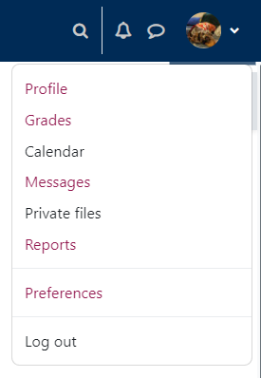

## Site Layout

There are four types of pages in Moodle:

* The **Home** Page
* The **Dashboard** Page
* The **My courses** Page
* Individual **Course** Pages – also known as **Moodle spaces**

Home Page

At the top of the **Home** page is a menu bar that includes a number of useful links and resources.

Having logged in successfully, both the menu bar and the home page will be expanded to provide you with functionality specific to your user account (e.g., such as access to your messages, Moodle spaces, or profile):



Moodle spaces can be accessed in a number of ways. Through the **My courses** link in the menu bar, through your personal **Dashboard**, or via the **Homepage** by clicking on the course **Tiles** that appear below the menu bar.

Each tile will contain a link to the Moodle space, course details, and an image of the Unit Convenor (if available).

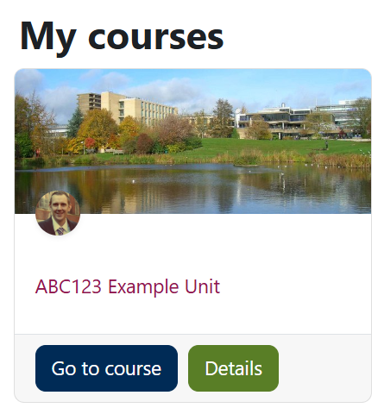

**Note:** If you cannot see any Tiles on the home page, Dashboard or My courses menu, this means you have not been enrolled on any Moodle spaces, or that your tutor has yet to make the Moodle space available. Your course team are responsible for ensuring you have access, so contact your department with any queries relating to access and they can check that you have been correctly enrolled on units in the Student Record System (SAMIS). Moodle draws the information on who needs access from SAMIS each night.

Dashboard

The **Dashboard** provides users with a personal view. By default, the dashboard shows a timeline of activities that require action (such as assessment submission dates) if these have been entered by your tutors, but you can add additional blocks if required.

My courses

The **My courses** menu presents a personal view of Moodle spaces that can be customised and navigated in a number of ways, for example by viewing Moodle spaces that are Past, Future or In progress.

Individual Course Pages – also known as Moodle Spaces

Each of your courses will have their own individual Course page, known as Moodle spaces.

### The Course Index

The **Course Index** is the name for the left panel (drawer) where you see the named sections in your Moodle space. It appears on every Moodle space and can be opened by clicking on the icon that looks like a bulleted list.

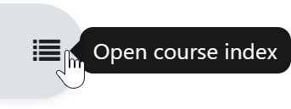

Once open, the drawer can be closed again by clicking the x that appears at the top of the panel.

### Course tool bar

When you access a Moodle space you will see a number of tabs across the top.

This tool bar is context sensitive so the tabbed content will vary depending where you are within Moodle at any time.



* + - * **Participants** is where you can view who are the other participants of the Moodle space.
      * **Unit / Course info** is where you will find a link to the unit description, and Library Lists.
      * **Assessments** provides quick access to assessed activities (assignments, quizzes, forums) as long as the course team has tagged these activities appropriately.
      * **Grades** takes you to the Gradebook. Note that any grades showing in Moodle are not confirmed until they have been considered by the appropriate Boards, and therefore might be subject to change.
      * **More** is where you will see an option to download content for offline viewing, if this has been enabled.
    1. BLOCKS

Moodle **Blocks** appear on the right-hand side of the content area. Blocks are located in a collapsible/expandable panel (allowing you to increase the size of the main content area).

Locating the block drawer

The block drawer is located to the right of your Moodle space. To expand it, click on the arrow that appears on the far right of the space:

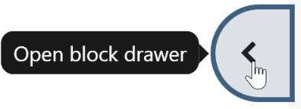

Should you wish to close the drawer again, simply click onto the cross that appears at the top of the drawer.

You should see three default blocks in the Block Drawer:

* + - * The **Activities** block, which gives you quick links to a range of the different activities in the Moodle space.
      * The **Panopto** block, where you will see links to any lecture recordings captured that are associated with the Moodle space.
      * The **Calendar** block which will highlight event dates, if these are being used.

In addition, your lecturer may have added additional blocks to this section.

# Navigation

There are a number of ways that you can move around your Moodle spaces, depending upon your preference.

## Using the Content Area

The most commonly used method of navigating around Moodle is via a combination of the links that appear in the content area of a Moodle space.

After logging on to Moodle, the **Home** page will display a list of those Moodle spaces that you have permission to access. You can navigate to any of these simply by clicking onto their title, at which point, any content or activities relating to that space will be displayed in the content area instead. By continuing to click on relevant links, you can choose your path directly.

To quickly return to the site Home page you can simply click on **Home** in the menu that appears across the top of the site.

## Using the Course Index

The Course index replicates the structure of your Moodle space content and is a quick way for you to find and navigate to specific items. Clicking on an item in the Course index opens it up directly in the main content area.

If activity completion is enabled, you will see circles to the left of the required activities. These change colour when the activity is completed, giving you a quick view of your progress.

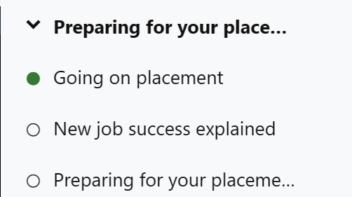

The Course index scrolls independently of the main central content area and if you click on an item in the Course index, it will immediately display in the central panel.

You can collapse individual sections in the Course index by clicking on relevant arrow icons:

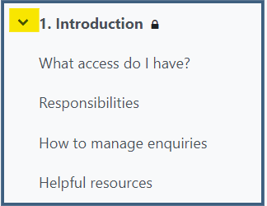

When a topic has been collapsed, the arrow changes shape to indicate it can be expanded again.

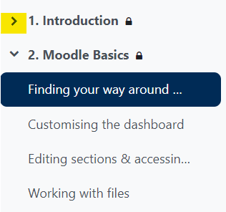

# Content Delivery

Each department uses Moodle in a slightly different way to support your studies, depending on the nature of the subject matter. You may find links to files, documents, journals, and websites that you are expected to read. You may find quizzes to take or videos to watch. Resources may be presented for the entire semester or may be released on a weekly basis.

# Assessments

You may be asked to upload assignments to Moodle or complete quizzes on Moodle during your studies.

## Uploading an assignment

As Moodle can accept most file types, make sure you follow the instructions in the assignment brief to ensure you are uploading the correct format for your course.

To upload an assignment:

* Visit the appropriate assignment submission point (you may be able to use the Assessments tab at the top of the page if it has been set-up by your tutor, or the Assignments link in the Activities Block to quickly navigate to this.)
* Click on the button to Add Submission and either drag and drop your file(s) onto the screen or navigate to select the appropriate file(s).
* Depending on the way the Submission point has been set up, you may need to accept a submission statement or confirm submission if the ability to upload a draft has been enabled. If the submission button is enabled for your assignment, once you click the submit button, you will not be able to modify your submission. Make sure you carefully read the instructions for the specific assignment to ensure you upload your assignment correctly and on time. Once you have submitted, you will see your **Submission status**. The Submission status will display the status of your submission, the **Grading status**, the **Time remaining** to assignment deadline, when your submission was **Last modified**, and a link to your **File submission**.

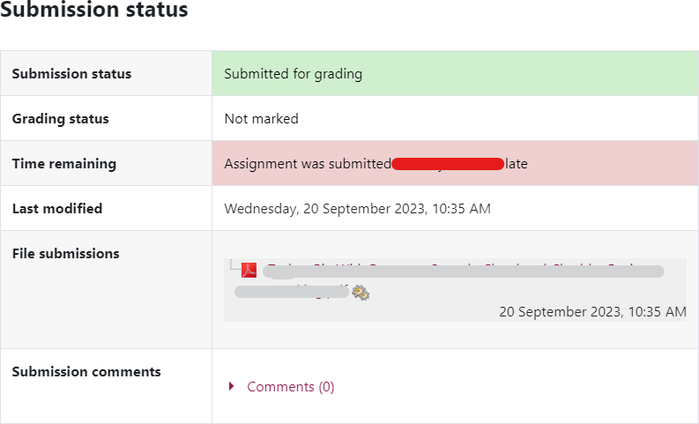

## Submitting a Quiz

A Moodle quiz can be set up in various ways, make sure you read and follow the instructions of the quiz before attempting the quiz and before submitting your answers.

To attempt a quiz:

* Click on the quiz link on the Moodle space, you can also use the Assessments link at the top of the page, or the Quizzes link in the Activities Block to quickly navigate to this, depending whether this has been set-up.
* Read the information to check you're in the right quiz and that you understand what you need to do in the quiz.
* When you are ready click on **Attempt quiz now**.

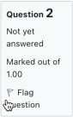

* Click on the **Next** button at the bottom of the page to see the next page of questions.
* Click on the **flag** in the box next to the question to put a temporary marker on it.
* You can jump to any question using the Quiz navigation block.

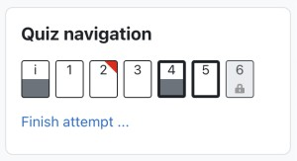

* + A flagged question is shown with a red triangle at the top right.
  + Questions on the current page are shown with a thicker border.
  + After viewing a description of a question, it is shown with the bottom half grey.
  + After saving an essay question, it is shown with the bottom half grey.
  + A dependent question is shown in grey with a padlock icon.
* The **Summary of attempt** page - reviews the questions and alerts you to questions not attempted.

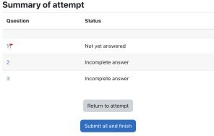

* + Click on **Return to attempt** to go back to the quiz.
  + Click on **Submit all and finish** to submit. Depending on how your quiz was set-up, a warning may pop up telling you that you can no longer change your answers.

# Alternative formats

Moodle is linked to a tool that allows you to download some of the resources and materials provided in different formats. For example, it may be able to download a Word document as an Audio file or in Braille.

## Downloading a resource in an alternative format

* To convert a file to an Alternative format, look for this symbol against a file.
* Choose the format you wish to receive the file in.
* You will be notified when the converted file is available.

# Contact and support

* Contact the [IT Service Desk](https://www.bath.ac.uk/locations/it-service-desk/) for any account issues.
* **You need to contact your Department/course team for any queries about using Moodle for your studies.**

# Appendix

## Summary of key icons and functions

|  |  |  |  |
| --- | --- | --- | --- |
| Assignment icon | **Assignment**  Used to submit files for marking. Integrated with the Ouriginal similarity checking service. | Glossary icon | **Glossary**  List of definitions – can be populated by either Teachers or Students. |
| Blog icon | **Blog**  Used to create a blog within a unit (which are separate to the core Moodle blog system). | Group choice icon | **Group Choice**  Allows students to enrol themselves in a group within a course. |
| Board icon | **Board**  A “post-it” board activity. | Group peer review icon | **Group peer review** Allows group members to anonymously rate contributions of others to group projects. |
| Book icon | **Book**  A multi-page resource in a book-like format, with chapters and subchapters. | H5p icon | **H5P**  Enables stand-alone H5P content to be uploaded and added to a course. |
| Choice icon | **Choice**  Similar to a poll. Often used to enable students to select seminar groups, etc. | Lesson icon | **Lesson**  Produces structured yet flexible learning paths. |
| Database icon | **Database**  Enables data to be input (by either Teachers or Students) and stored in a searchable format. | Page icon | **Page**  Page can display text, images, sound, video, web links and embedded code. |
| Quiz icon | **Quiz**  Online quiz tool. | Forum icon | **Forum**  An asynchronous discussion tool. |

|  |  |  |  |
| --- | --- | --- | --- |
| Fair allocation icon | **Fair Allocation**  Allows participants to rate choices. Participants can then be distributed automatically to the available choices according to their ratings. | Zoom icon | **Zoom**  To join a video conferencing  meeting. |
| Feedback icon | **Feedback**  A survey for collecting  feedback from participants. | URL icon | **URL**  A link to a web resource. |
| Feedback fruits icon | **FeedbackFruits**  Provides a series of assessment and feedback  options (not used by all departments). | Wiki icon | **Wiki**  A series of web pages that can be edited by anyone.  Useful for group projects. |
| File icon | **File**  A downloadable file. | Workshop icon | **Workshop**  Facilitates peer and self-  assessment. |
| Folder icon | **Folder**  Multiple files in a folder that can be downloaded. |  |  |
|  |  |  |  |
|  |  |  |  |



This work is licensed under a [Creative Commons Attribution-ShareAlike 3.0 Unported License.](http://creativecommons.org/licenses/by-sa/3.0/deed.en_GB)