Guidelines to Enhance Students’ Engagement in Distance Learning

Abstract: Our pilot compared Padlet boards, Evolve drag-and-drop activities, interactive videos, and a Microsoft Teams social hub. Interactive video produced the highest engagement (mean 4.5/5). Drag-and-drop and Padlet added desirable variety, while the Teams uptake was low. This report summarises the data and provides evidence-informed guidance for scaling these tools across distance learning- programmes.

1 Introduction
Distance learning presents unique challenges, with students often reporting a lack of engagement with both instructors and peers compared to face-to-face settings [1]. This issue is common across university departments offering distance learning programs. This project aimed to explore readily available tools and methods integrated within the University's existing platforms (Moodle, Engage) to enhance student engagement. Our exploration focused on criteria of Effectiveness (fostering student-teacher and peer-peer engagement), Usability (ease of use for staff and students), and Accessibility/Availability (integrated within existing university systems). We piloted a suite of readily available- tools, such as interactive videos with H5P or Echo360, drag-and-drop activities using Evolve, Padlet boards, Mentimeter live polls, and a Microsoft Teams social hub in two online units. Quantitative ratings were gathered via Mentimeter (5--point Likert scales), and qualitative comments were collected through open-text prompts. This report synthesises the findings and provides practicable- guidance (Why / When / How) for scaling effective activities across distance learning programmes.

2 Method in brief
Week | Focal tool | Sample size (responses) | Instruments
1 | Padlet board | n ≈ 18 | 4 Likert items + open comments
2 | Drag-and---drop (Evolve) | n ≈ 17 | 4 Likert items + open comments
3 | Interactive video | n ≈ 20 | 4 Likert items + open comments
All | Teams social hub usage | - | 1 multiple‑choice item
Note: Exact n fluctuated week to week; responses were anonymous. Validated scales: Items adapted from the SAES engagement scale [2].

3 Headline findings

3.1 Padlet board
- Satisfaction 4.0/5; desire for more boards 3.8/5.
- Preference slider (1 online board → 5 discussion forum) averaged 2.8, indicating a slight preference towards Padlet over traditional Moodle forums.
- Students valued informality and "flashcard" feel, but cautioned that exclusive use of Padlet could become tedious; variety is essential.
- Accessibility flag: one student had not tested Padlet on mobile, whereas forums are routinely accessed on phones.

3.2 Drag and drop done with Evolve
- Satisfaction 3.9/5; desire for more drag-and---drop 4.1/5 (highest demand increase).
- Preference slider (1 Mentimeter live poll → 5 other interactive) scored 3.1, favouring additional interactive formats over live polls alone.
- Key improvement request: allow students to review answers post-submission for notetaking and reflection.

3.3 Interactive video done with Echo360
- Outstanding performance across all metrics: satisfaction 4.5/5, want more 4.5/5, interactivity preference 4.5/5, perceived engagement 4.5/5.
- Qualitative comment: “More such interactive videos might be helpful.” No negative remarks recorded.
- Aligns with research showing interactive video improves comprehension and retention compared with passive viewing [3].

3.4 Social hub done with Microsoft Teams
- Low routine usage (majority ‘Rarely’ / ‘Never’); privacy concerns raised about Microsoft data collection.
- Students appreciated the option but did not rely on it for weekly study, and some valued reduced compulsory social presence due to anxiety.

4 Guidelines (Why | When | How)
4.1 Online boards: Padlet vs discussion forums
 | Why (evidence & rationale) | When to deploy
Informality & Multimedia | Satisfaction 4.0/5; slight preference for Padlet. Padlet's visual, flexible format lowers the barrier for quick contributions, brainstorming, and multimedia sharing, fostering creative expression and peer interaction [4]. | Icebreakers, resource curation, brainstorming, visual galleries, quick Q&A.
Community & Peer Learning | Both tools provide asynchronous spaces crucial for community building in distance learning. Boards can feel more immediate for sharing, while forums support deeper, threaded peer-to-peer learning. | Activities requiring peer feedback (e.g., brief idea sharing on Padlet, draft critiques in Forum); ongoing Q&A spaces; social/informal connection points.

How to implement:
Padlet boards can be embedded directly into Engage/Moodle. To embed it into Engage, contact Risepoint, who can assist with creating and embedding the Padlet board. Please note that the free Padlet account allows up to 3 boards.
Alternatively, teachers can create Padlet boards themselves by logging into Padlet using their university credentials. However, be aware that boards created this way are tied to the individual’s university account. This may pose a risk if the account is ever deactivated, as access to the boards could be lost.
Tips:
- Rotate usage: e.g., Week 1 Padlet, Week 2 forum, and Week 3 Padlet, etc., playing to the strengths of each tool and maintaining variety (addresses student feedback)
- Instructor presence is key: Model good contributions, prompt deeper reflection, summarise key themes.
- Address mobile accessibility concerns by testing Padlet layouts or using Moodle Board if integrated.
- Ensure Padlet accessibility settings (e.g., contrast) are used. Interactive boards of this type have been linked to measurable critical-thinking gains [5].
- Enable Reactions to boost engagement (Like ❤️, Vote 👍👎, Star ⭐️, Score 💯). These reactions, plus Padlet comments, can mimic a peer-review workflow across Engage and Moodle. Hypothes.is and FeedbackFruits also offer structured peer review activity on Moodle, but they are not yet compatible with Engage.

Additional forums & pacing tweaks
- Persist weekly prompts: After a new teaching week begins, copy the previous week’s discussion question into the main Q&A forum as its own thread so the conversation stays visible and can continue.
- Instructional language: Rephrase instructions to “Post your thoughts and feel free to reply to others at any time” to remove the “post-then-reply” barrier noted by students.
- Gentle deadlines: Keep the Monday midday cut-off as a motivator but make it explicit that later contributions are welcome; this supports students managing busy schedules or different time zones.

4.2 Interactive activities: Evolve drag-and-drop vs Mentimeter live polls
 | Why (evidence & rationale) | When to deploy
Retrieval Practice | High desire for more (4.1/5); activities like drag-and-drop require active recall, strengthening memory traces [6]. Promotes generative learning beyond simple recognition. | After key readings or complex diagrams (anatomy, workflows); pre-topic knowledge activation.
Variety & Engagement | Preference data suggests value in diverse interactive formats beyond live polls alone (3.1/5). Different activities cater to different learning preferences and break monotony, while fostering higher-order skills such as critical thinking [5]. | Interspersed within longer content modules; formative checks during or after topics, icebreakers (Mentimeter).
How to implement:
In Engage, drag-and-drop activities are created using Evolve. Learn more about the tool here.
These activities appear as draggable cards that students can move into designated drop zones. To set up a drag-and-drop activity, please contact Risepoint and provide the following details:
- Number of cards and the text for each card
- Number of drop zones and the text for each zone
- Whether incorrect items should be rejected by the drop zones
- Number of attempts allowed
- The correct solution (i.e., which card belongs in which drop zone)
- Whether the cards should be randomized
- Feedback text to be shown after submission
- Preferred card and background colours
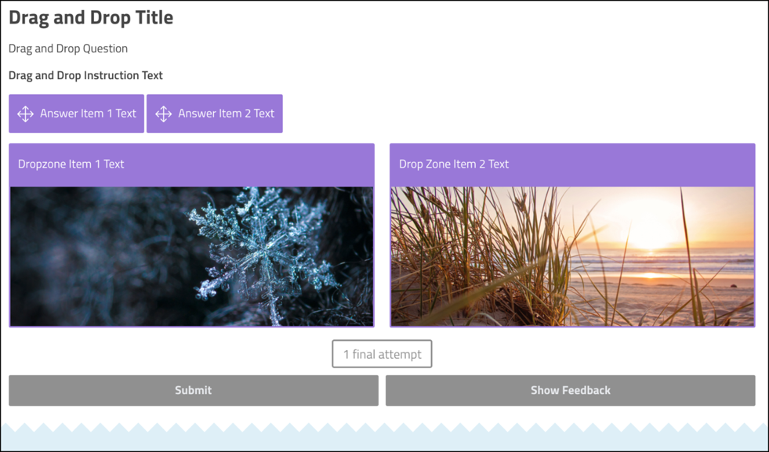
Figure 1: Example of drag-and-drop activity. Source: Drag and Drop Component by Intellum Documentation
Tips:
- Remember to enable answer-review & downloadable constructive feedback to support students’ learning from their errors. This suggestion is per the students’ request for later revising purposes.
- Limit drag-and-drop to 6–8 items to manage cognitive load.
- Pair asynchronous activities (Evolve) with instant Mentimeter polls in live sessions to surface misconceptions quickly and visually.
- Ensure clear instructions.
- Match activity type to learning objective (e.g., Evolve/Echo360 for self-paced checks, Mentimeter for group brainstorming/polling).
- Ensure accessibility (WCAG compliance) for all interactive elements.

4.3 Interactive videos vs static recordings
 | Why (evidence & rationale) | When to deploy
Engagement | Highest satisfaction & engagement (4.5/5). Clickable elements require active cognitive processing [7] and reducing mind-wandering. | Weekly core concept briefings; pre-assessment refreshers.
Active Learning | Promotes immediate application or self-assessment, reinforcing learning points more effectively than passive viewing [8]. | Introducing complex topics; summarising key takeaways where self-check is useful.
How to implement:

You can create instructional videos using PowerPoint or another presentation tool. Here are some tips and important steps:
- Use images on each slide and keep text minimal to maintain engagement.
- Record voice-over narration for each slide. You can do this yourself or request a voice actor via Risepoint.
- Add transcripts in the presenter notes section to help with the voice-over.
Embedding in Engage:
- Contact Risepoint to embed your video as an interactive video, usually using Echo360. Learn more about Echo360 polls here.
- While Panopto can also be used to create interactive videos, it may cause issues in Engage due to additional login requirements for students.
Accessibility:
- Ensure your video includes captions for accessibility.
- Share your transcripts with Risepoint so they can verify and apply accurate captioning.
Tips:
- Keep video segments ≤ 10 min between interactions to align with attention spans.
- Embed 2–3 varied interactions (e.g., quizzes, polls, reflection prompts) for formative feedback & knowledge checks.
- Provide accessible captions & transcripts.
- End with a Padlet prompt or quiz to feed the discussion.
- Ensure quiz feedback is constructive.
- Use analytics (if available) formatively to identify common misunderstandings.

4.4 Teams social hub
Issues | Recommendation
Low engagement | Run fortnightly ‘drop-in’ sessions tied to assignment milestones; advertise in Moodle announcements.
Privacy worries | Add an FAQ page outlining institutional data policy [9] and suggest optional encrypted channels (e.g., Signal) for self-organised study groups.
Accessibility | Encourage use of desktop or mobile app; provide quick-start video & alt--text- for posted images.
How to implement:
The Social Hub was developed using Microsoft Teams, as it is already widely used by students, primarily for group discussions. During several virtual Town Halls, students confirmed that Teams is one of their preferred platforms for socialising.
Tips:
- Use Viva Engage (formerly Yammer) to create community-style tabs for broader discussions and announcements.
- Set up private channels to support group work or focused discussions. Be sure to add a Calendar tab in each room so students can schedule and “book” meetings.
- Post a clear set of community guidelines in the first channel to promote respectful interaction. For example: “Please avoid posting any hateful, defamatory, obscene, discriminatory, or harassing comments, images, or videos, or anything that could be deemed offensive to others.”

5 Action plan for scale-up
- Embed interactive videos in all core units AY 2025/26; create staff training screencast (≤ 5 min).
- Convert existing static quizzes to drag-and---drop/Evolve with answer-reveal- functionality by Week 6 of each semester.
- Padlet/forum integration pilot in Semester 1; gather analytics on thread continuity.
- Revise forum wording & deadlines across Moodle templates by July 2025.
- Publish privacy guidance for Teams and trial an alternative encrypted platform with a volunteer cohort.
- Looking ahead, student-generated media projects have also been shown to raise engagement and develop employability skills [10]; exploring a ‘students-as-producers’ model will form the next phase of our work.

6 Limitations & next steps
- Small sample sizes; replicate with larger cohorts.
- Self-report bias is possible [11]; triangulate with LMS analytics.
- Explore accessibility further (mobile testing, screen-reader- compliance).

7 Conclusion
Interactive H5P videos delivered the clearest engagement gains, with drag-and--drop and Padlet activities offering valuable variety when thoughtfully sequenced. -Maintaining flexibility, clarifying participation instructions, and addressing privacy concerns will further enhance distance learning- students’ sense of connection and satisfaction.

Cited tools
- Evolve
- Echo360
- Padlet
Reference
[1] Fiorella, L. & Mayer, R.E., 2016. Eight ways to promote generative learning. Educational Psychology Review, 28(4), pp.717-741.
[2] Mallardo, I. et al. 2021. A new measure for the assessment of the university engagement: The SInAPSi academic engagement scale (SAES). Current Psychology, 40, pp.13211335.
[3] Hung, I.C. & Chen, N.S., 2018. Embodied interactive video lectures for improving learning comprehension and retention. Computers & Education, 117, pp.116131.
[4] Salmon, G., 2013. E-Moderating: The key to online teaching and learning. 4th ed. Routledge.
[5] Blyznyuk, T. & Kachak, T., 2024. Benefits of interactive learning for students’ critical thinking skills improvement. Journal of Vasyl Stefanyk Precarpathian National University, 11(1), pp.94–102. Available from: https://doi.org/10.15330/jpnu.11.1.94-102
[6] Roediger, H.L. & Karpicke, J.D., 2006. Test-enhanced learning. Psychological Science, 17(3), pp.249255.
[7] Garrison, D.R., Anderson, T. & Archer, W., 2000. Critical inquiry in a text-based- environment. The Internet and Higher Education, 2(2-3), pp.87-105.
[8] Sweller, J., 2011. Cognitive load theory. In: Psychology of Learning and Motivation, 55, pp.3776.
[9] University of Bath, 2024. Data Protection Policy. Available from: https://www.bath.ac.uk/legal-information/data-protection-policy/ [Accessed 17 April 2025]
[10] Ryan, B., 2013. A walk down the red carpet: students as producers of digital video-based knowledge. International Journal of Technology Enhanced Learning, 5(1), pp.24–41. Available from: https://doi.org/10.1504/IJTEL.2013.055950
[11] González-Betancor, S.M., Bolívar--Cruz, A. & Verano--Tacoronte-, D., 2017. Self-assessment- accuracy in higher education: The influence of gender and performance of university students. Active Learning in Higher Education, 20(2), pp.101-114. https://doi.org/10.1177/1469787417735604 (Original work published 2019).

Appendix A Student Activity-Feedback Surveys
Padlet Board Feedback
No. | Question | Response scale (1 – 5)
1 | I am satisfied with the Padlet board. | 1 = Not satisfied at all … 5 = Very satisfied
2 | I would like to see more Padlet boards. | 1 = Strongly disagree … 5 = Strongly agree
3 | Between an online board (e.g. Padlet) and a discussion forum, I would prefer… | 1 = Online board … 5 = Discussion forum
4 | I feel more engaged with the unit content when using the Padlet board. | 1 = Not at all … 5 = Very significantly
Open-ended prompt:
Please share any additional feedback or suggestions on how to improve the Padlet activity.
Drag-and-Drop (Evolve) Feedback
No. | Question | Response scale (1 – 5)
1 | I am satisfied with the Drag-and-Drop activity. | 1 = Not satisfied at all … 5 = Very satisfied
2 | I would like to see more Drag-and-Drop activities. | 1 = Strongly disagree … 5 = Strongly agree
3 | Between a live Mentimeter poll and another interactive activity (e.g. Drag-and-Drop, interactive cards), I would prefer… | 1 = Mentimeter … 5 = Other interactive activity
4 | I feel more engaged with the unit content through the Drag-and-Drop activity. | 1 = Not at all … 5 = Very significantly
Open-ended prompt:
Please share any additional feedback or suggestions on how to improve the Drag-and-Drop activity.

Interactive Video (H5P) Feedback
No. | Question | Response scale (1 – 5)
1 | I am satisfied with the interactive video. | 1 = Not satisfied at all … 5 = Very satisfied
2 | I would like to see more interactive videos. | 1 = Strongly disagree … 5 = Strongly agree
3 | Between a regular video and an interactive video, I would prefer… | 1 = Regular video … 5 = Interactive video
4 | I feel more engaged with the unit content through the interactive video. | 1 = Not at all … 5 = Very significantly
Open-ended prompt:
Please share any additional feedback or suggestions on how to improve the interactive video activity.

Notes on Scales:
- All closed items use a five-point Likert scale with ascending positivity.
- Item 3 in each survey functions as a comparative preference slider anchored at 1 = existing/alternative tool and 5 = new tool.

