Groupwork – Project Plan

Both staff and students tend to agree that group assessment can be one of the hardest things to navigate at University. But it can also be positive, since different members have different skills and approaches.

Reflect on how you work together. Make sure you have a plan.

Evaluate your group’s strengths
We are all good at different things. For example, some are good at calculations and spreadsheets; some are good at sketches and laying out information clearly; others might have a good understanding of the mechanical components and how bearings can be used in practice.

We also all work in a different way in terms of pace: some like to get started early on a task; some work as a steady rate, whereas others might need the pressure of a deadline to get them working.
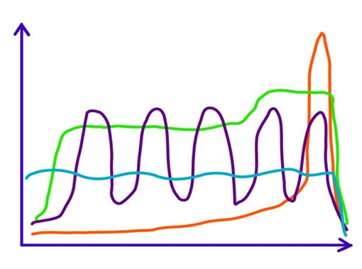
Talk as a group and fill out the table below with a row for each member.

Group member name | Which parts of the project are you most comfortable with? | How do you work – get started quickly, work steadily, or leave it until the end?

Plan your project
Review the brief for this assignment. What are the main tasks you will need to do as a group to complete your submission? List them here.

Break down your to do list
Now you have identified the main tasks, it can be useful to break these down to a level that works for everyone in the group. For example, rather than list a task such as ‘create technical drawings’, you could break this down further to read ‘create shaft part in Inventor’, ‘create assembly with transmission and bearings etc’, ‘set up template 2D drawings’, ‘populate 2D drawings with views’, etc.

Take the tasks that you will be tackling above, and break them down into smaller tasks for as long as you find useful. The amount we need to break down tasks fluctuates depending on the complexity of the tasks themselves and how we are feeling - some days we feel more motivated than others! The important thing to remember is to break things down to a level that feels manageable and will enable you to see progress.

Allocate tasks/roles

Based on your discussion about strengths, and how everyone prefers to work, are there particular aspects that would play to individual group members’ strengths?

Allocate tasks and roles in the table below.

Week 1 | Week 2 | Week 3 | Week 4

