Template for Student Group video presentation recording instructions

You can choose one of the options below to provide your students with guidance for recording and uploading a group video presentation to Re:View

There are other ways to create video/audio files depending on the hardware and software available to you. Below are 3 options using software available to you at the University for recording group presentations.

Group Assignment Presentation Recording options:

Option 1 Overview:
- Students collaboratively produce Powerpoint presentation using OneDrive.
- Students narrate presentation in Powerpoint and export as MP4 video file.
- Students upload video to Re:View (Panopto) Assignment folder.
- Students copy URL link to recording into Moodle Assignment submission text box

Option 2 Overview (Microsoft Teams meeting):
- Students organise Microsoft Teams meeting.
- One student records the meeting. Students take turns in presenting.
- At the end of the meeting, one student downloads the recording from OneDrive.
- Students upload video to Re:View (Panopto) Assignment folder.
- Students copy URL link to recording into Moodle Assignment submission text box

Option 3 Overview (for Group Presentation without creating a narrated Powerpoint):
- Students produce an MP4 video file via one of various non-Powerpoint options.
- Students upload recording to Re:View (Panopto) Assignment folder.
- Students copy URL link to recording into Moodle Assignment submission text box

Option 1 Protocol:

Step 1: Creating your Presentation
We suggest that you produce a Powerpoint presentation in OneDrive. This will enable all members of the team to work on it collaboratively. Please see a link to information about how to share and edit in OneDrive: https://support.office.com/en-gb/article/worktogether-on-powerpoint-presentations-0c30ee3f-8674-4f0e-97be-89cf2892a34d:

For helpful tips for collaborating visit this site and scroll down to watch a video: https://business.tutsplus.com/tutorials/powerpoint-team-collaboration--cms-29630

To record a narration over the Powerpoint slides go to Slide Show and click on Record Slide Show.

Step 2: Saving your Presentation:
- Click File
- Export
- Create a Video
- Click on the Create Video Icon
- In the Save As Window name your work (see naming protocol below) and click Save As you will see it will be saved in MPEG-4 format.

Step 3: Uploading Your Presentation to Re:View (Panopto):

Once you have completed your presentation and all members of the team are happy with the final version then one member of the team will need to upload it to Re:View (Panopto), the University’s lecture capture system.

Uploading your Recording to Re:View

- Go to the Assignment URL you have been given (provided in the submission point information. There is a different URL for each module). Log in to Re:View. Click on the blue ‘Create’ button in the toolbar at the top of the screen and select ‘Upload media’.
Important: Do NOT upload to ‘My Folder’ as this is your personal area. Ensure that you are uploading to the course folder labelled [assignments]. E.g. PL34249: PL34249 French language [assignments]
- You will then see the option to upload the recording from your computer. This could take some time depending on your internet connection. Ensure you upload your file as an .MP3 or .MP4.
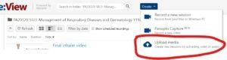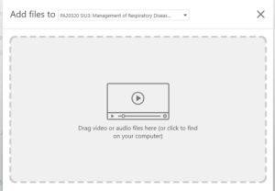

Linking to a Moodle submission point

- Link to your video submission by copying the URL from the recording in Re:View and pasting it into the online text box in the relevant Moodle submission point. To find the URL, click ‘Share’ next to your submission, and then copy the link given at the top of the page.

A step by step video instruction guide to uploading your file and copying the link can be found here:
Student Upload to Assignment folder and insert link to Moodle submission point

Allow plenty of time to upload your recording as there may be technical issues such as loss of internet connection, high demand on the Panopto server, or slow uploading times. We suggest uploading your video 48 hours before your deadline to mitigate for unforeseen technical issues.

In case of any technical issues, please also make sure you have kept a saved copy of your work.

Some generic Frequently Asked Questions for students are available on the CLT Hub https://teachinghub.bath.ac.uk/how-to-use-review-for-students/

Naming your Presentation:

Please label your presentation as follows: BSc xxxxxxxxxxx 2020,
Team Name/Number (Initials of Academic Advisor.Second Marker)

Eg BSc Business FYP Viva Presentation 2020 Team 15 (TH.TB)

Please note that once you have uploaded your presentation other team members will not be able to view it so please ensure you are all happy with the completed version.

Viva or Group Contribution Sheet:

Complete the contribution sheet which is available on the Moodle page XX XXXXXXXX and one member of the team should email it to xxxxxxxxx .bath.ac.uk by the deadline of <time> on <xxxxxx 00 xxxxx> 2020.

If you have an electronic signature please include it, if not then the full name of each team member printed in the Student Signature section will be sufficient.

Option 2 Protocol

Microsoft Teams meeting

The ultimate aim is to upload an MP4 video file to the assignment folder in Re:View (Panopto). There are many ways to do this – here are some options if you do not wish to create a narrated PowerPoint.

Step 1: Setup a Microsoft Teams meeting

Set up a Microsoft Teams meeting and invite the other members of your team. Students can create a meeting directly from the Teams app, in the browser, or in Outlook. All students have access to Microsoft Teams with their University email address and password – log in at https://teams.microsoft.com/

Step 2: Record your meeting
One person should press record during the meeting. Depending on which version of Teams you are using, click the 3 dots and then Start Recording.

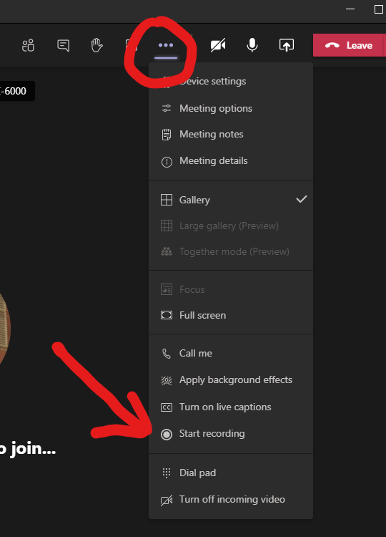

Step 3: Take turns to present
Each group can take turns to present and share their slides and/or screen.

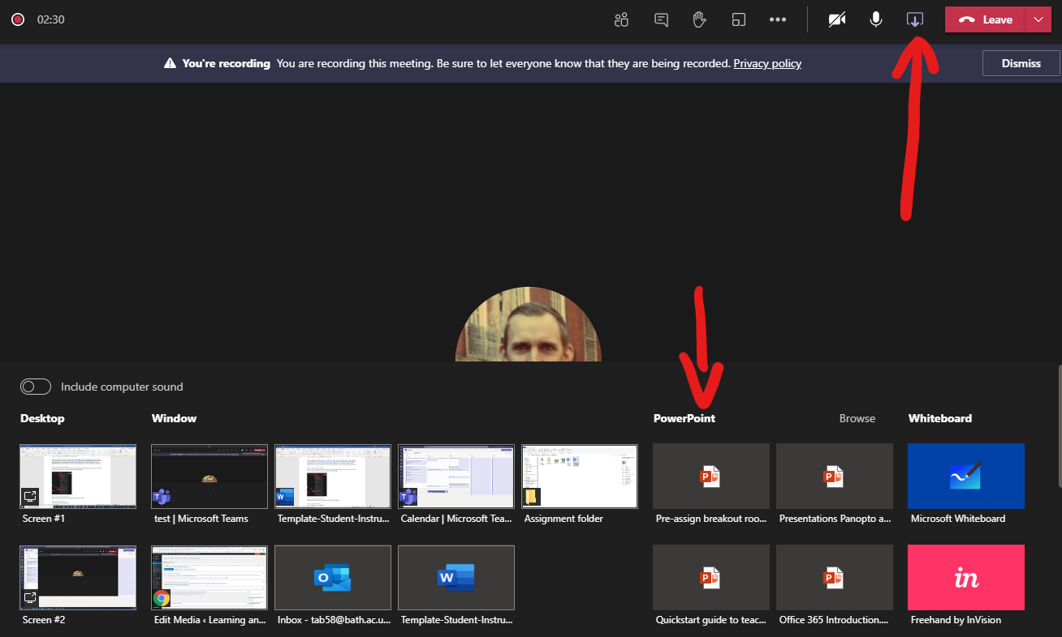

Step 4: Stop recording
The recording can be stopped by clicking the three dots and Stop Recording.

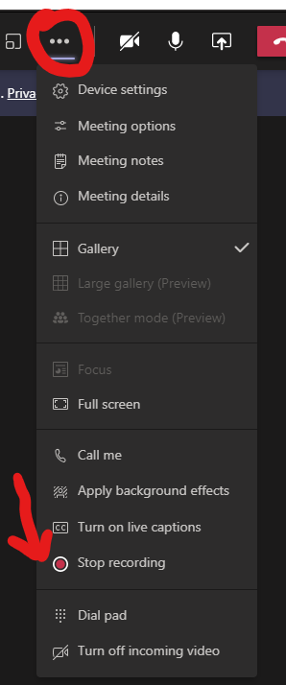

Step 5: Download the recording from OneDrive.
The recording will appear in the meeting chat. It can be downloaded by one person and saved to their computer.
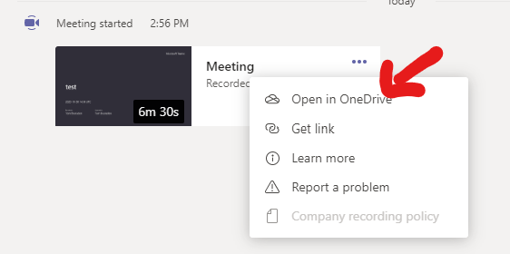

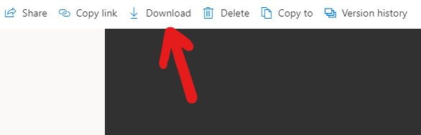

Step 6: Upload to Review Assignment folder and post video URL to Moodle Assignment

Once you have completed your presentation and all members of the team are happy with the final version then one member of the team will need to upload it to Re:View (Panopto), the University’s lecture capture system.

Uploading your Recording to Re:View

- Go to the Assignment URL you have been given (provided in the submission point information. There is a different URL for each module). Log in to Re:View. Click on the blue ‘Create’ button in the toolbar at the top of the screen and select ‘Upload media’.
Important: Do NOT upload to ‘My Folder’ as this is your personal area. Ensure that you are uploading to the course folder labelled [assignments]. E.g. PL34249: PL34249 French language [assignments]
- You will then see the option to upload the recording from your computer. This could take some time depending on your internet connection. Ensure you upload your file as an .MP3 or .MP4.

Linking to a Moodle submission point

- Link to your video submission by copying the URL from the recording in Re:View and pasting it into the online text box in the relevant Moodle submission point. To find the URL, click ‘Share’ next to your submission, and then copy the link given at the top of the page.

A step by step video instruction guide to uploading your file and copying the link can be found here:
Student Upload to Assignment folder and insert link to Moodle submission point

Allow plenty of time to upload your recording as there may be technical issues such as loss of internet connection, high demand on the Panopto server, or slow uploading times. We suggest uploading your video 48 hours before your deadline to mitigate for unforeseen technical issues.

In case of any technical issues, please also make sure you have kept a saved copy of your work.

Some generic Frequently Asked Questions for students are available on the CLT Hub https://teachinghub.bath.ac.uk/how-to-use-review-for-students/

Naming your Presentation:

Please label your presentation as follows: BSc xxxxxxxxxxx 2020,
Team Name/Number (Initials of Academic Advisor.Second Marker)

Eg BSc Business FYP Viva Presentation 2020 Team 15 (TH.TB)

Please note that once you have uploaded your presentation other team members will not be able to view it so please ensure you are all happy with the completed version.

Viva or Group Contribution Sheet:

Complete the contribution sheet which is available on the Moodle page XX XXXXXXXX and one member of the team should email it to xxxxxxxxx .bath.ac.uk by the deadline of <time> on <xxxxxx 00 xxxxx> 2020.

If you have an electronic signature please include it, if not then the full name of each team member printed in the Student Signature section will be sufficient.

Option 3 Protocol

Creating a group presentation without creating a narrated PowerPoint.

The ultimate aim is to upload an MP4 video file to the assignment folder in Re:View (Panopto). There are many ways to do this – here are some options if you do not wish to create a narrated PowerPoint.

Step 1: Setup a Collaborative OneDrive folder
Set up a OneDrive folder and give each of the group members editing access. One way to access OneDrive is to log into http://office.com with your University of Bath email address and password. You have access to many of the applications in the Office suite, such as PowerPoint, Word and OneDrive. This can be the place to share files with group members.

Step 2: Recording your Presentation

Option 1 – Use the Panopto desktop recorder within Re:View

Each group member records a video separately on their computer. One way to do this is directly into Re:View by installing the Panopto desktop recorder.
How do I record directly into Re:View?
How do I download the Panopto desktop recorder?
We suggest that if you are recording a group presentation, then each member records their own section of video into ‘My folder’ which is their own private area in Re:View. Once happy with this and having performed any basic editing, they can download the recording to their computer.

Option 2 – Use separate recording software
There are many other ways to record video, such as PowerPoint screen record for Windows, iMovie for Mac, paid for software like Adobe Premiere Pro or even just using your mobile phone recording function.
Note: If using a Mac, you may need to convert from a MOV to an MP4 file.
By the end of this step you should have your part of the group video presentation downloaded to your own computer.

Step 3: Save all videos to the OneDrive folder
Each group member now has a video file which they should upload to the group’s shared OneDrive folder (or another area is you have decided not to use OneDrive for any reason).

Step 4: Stitch all videos together
Nominate one person to download the group’s videos and ‘stitch’ them together.

Option 1: Stitch videos together using Re:View
It is possible to ‘stitch’ together a series of videos using the basic editing functionality in Re:View. To do this:
- Download each member’s video from OneDrive or wherever they are saved.
- Upload the videos to ‘My Folder’ in Re:View.
- Splice the videos together by ‘Adding a clip.’
- Rename and then copy or move the newly created video to the appropriate assignment folder. This will typically be name: <Course name> [assignments].
You may also wish to download it again too to put back in a OneDrive folder for the other members of the group to view.

Option 2: Stitch videos together using other software
Multiple recordings can also be stitched together in software such as iMovie or Microsoft Photos. The aim is to create an MP4 that you can upload to Re:View, so it doesn’t matter what software you use as everybody will have different software available to them.

Step 5: Upload to Review Assignment folder and post video URL to Moodle Assignment

Once you have completed your presentation and all members of the team are happy with the final version then one member of the team will need to upload it to Re:View (Panopto), the University’s lecture capture system.

Uploading your Recording to Re:View

- Go to the Assignment URL you have been given (provided in the submission point information. There is a different URL for each module). Log in to Re:View. Click on the blue ‘Create’ button in the toolbar at the top of the screen and select ‘Upload media’.
Important: Do NOT upload to ‘My Folder’ as this is your personal area. Ensure that you are uploading to the course folder labelled [assignments]. E.g. PL34249: PL34249 French language [assignments]
- You will then see the option to upload the recording from your computer. This could take some time depending on your internet connection. Ensure you upload your file as an .MP3 or .MP4.

Linking to a Moodle submission point

- Link to your video submission by copying the URL from the recording in Re:View and pasting it into the online text box in the relevant Moodle submission point. To find the URL, click ‘Share’ next to your submission, and then copy the link given at the top of the page.

A step by step video instruction guide to uploading your file and copying the link can be found here:
Student Upload to Assignment folder and insert link to Moodle submission point

Allow plenty of time to upload your recording as there may be technical issues such as loss of internet connection, high demand on the Panopto server, or slow uploading times. We suggest uploading your video 48 hours before your deadline to mitigate for unforeseen technical issues.

In case of any technical issues, please also make sure you have kept a saved copy of your work.

Some generic Frequently Asked Questions for students are available on the CLT Hub https://teachinghub.bath.ac.uk/how-to-use-review-for-students/

Naming your Presentation:

Please label your presentation as follows: BSc xxxxxxxxxxx 2020,
Team Name/Number (Initials of Academic Advisor.Second Marker)

Eg BSc Business FYP Viva Presentation 2020 Team 15 (TH.TB)

Please note that once you have uploaded your presentation other team members will not be able to view it so please ensure you are all happy with the completed version.

Viva or Group Contribution Sheet:

Complete the contribution sheet which is available on the Moodle page XX XXXXXXXX and one member of the team should email it to xxxxxxxxx .bath.ac.uk by the deadline of <time> on <xxxxxx 00 xxxxx> 2020.

If you have an electronic signature please include it, if not then the full name of each team member printed in the Student Signature section will be sufficient.

