PHEAF or CLT Professional Development

Defaults settings:
Confirmation email automatically sent when someone books on an event.
Reminder email 7 days before the event.
Emails are sent from clt@bath.ac.uk.

EMAILS signed off from the contact name (i.e. the person who created the event)
- Booking confirmed
- Booking cancelled
- Reminder email

This means that if a participant replies to the email, those who monitor the clt@bath inbox will know who to forward it to.

Confirmation and reminder emails may still go to the Spam/Junk folder (a potential fix is an ongoing development!)

Custom Automated Emails:
EMAIL defaults can be amended using the Custom Automated Emails section on the page.
Attendee Emails
- Ignore Pending and Rejected
- Confirmed booking – change drop-down menu to Enabled and edit the email content. DO NOT remove the existing placeholder content as this provides the relevant information for the event. You can add new lines of text (e.g. a reminder to complete some pre-work) or change the greeting or senders name (E.g. if you don’t want the contact's name on the email you can change this to ‘Centre for Learning and Teaching’).

Event Owner Emails – ignore these.

Create a new event:
Events > New Event

Note: If wanting to re-use an existing event, use the Copy feature (not duplicate) to copy it:
- Only copy 1 event at a time.
- Update the event page URL to match the new event title.
- Update the event details.

Accessibility
To ensure the page content is accessible please remember:
- Add alt-text to any images you add to the event description
- Use <h3> Heading 3 for the event headings (e.g. Target Audience, Event Details etc.)

Title: this will appear on the Event page (try to keep it relatively short)

Event Description: (information to go on the Event page)

Target Audience
Recommended for / Of interest to
All teaching staff / Probationers / All staff / DoTs/ADEs etc.

Event Details
The first paragraph should be a brief (30 words maximum) overview of the workshop/event. This can then be copied into the excerpt (further down the page) for when the event is displayed in an events list or on the events calendar.

Full description or bullet point list specifying what the event or workshop will include.

Learning Outcomes
Bullet list of things that can be achieved as a result of attending this session.

Speaker(s)
Names of presenter(s).

Preparatory work or special requirements
E.g. pre-reading, or the need to bring examples to the workshop/event.

Confirmation and reminder emails may go to the Spam/Junk folder – remind participants to check.

Include this disclaimer where appropriate:
For those not on probation, a record of attendance will be uploaded to iTrent for staff development purposes. Please indicate in the ‘Specific Requirements’ box when booking if you do NOT wish for your attendance to be uploaded to iTrent.

When:

Date: | Identify the start and end by clicking twice on a chosen day.
Time (Events start at __ to __): | Alter the start and end times. If the event is for academic staff, consider the academic timetable and schedule after lectures are due to finish (where possible)

Event categories (highlight ONE):

PHEAF or CLT PDP

Bookings/Registration to edit as appropriate - suggested settings in screenshot:

Click the ‘Enable registration for this event’ check box.

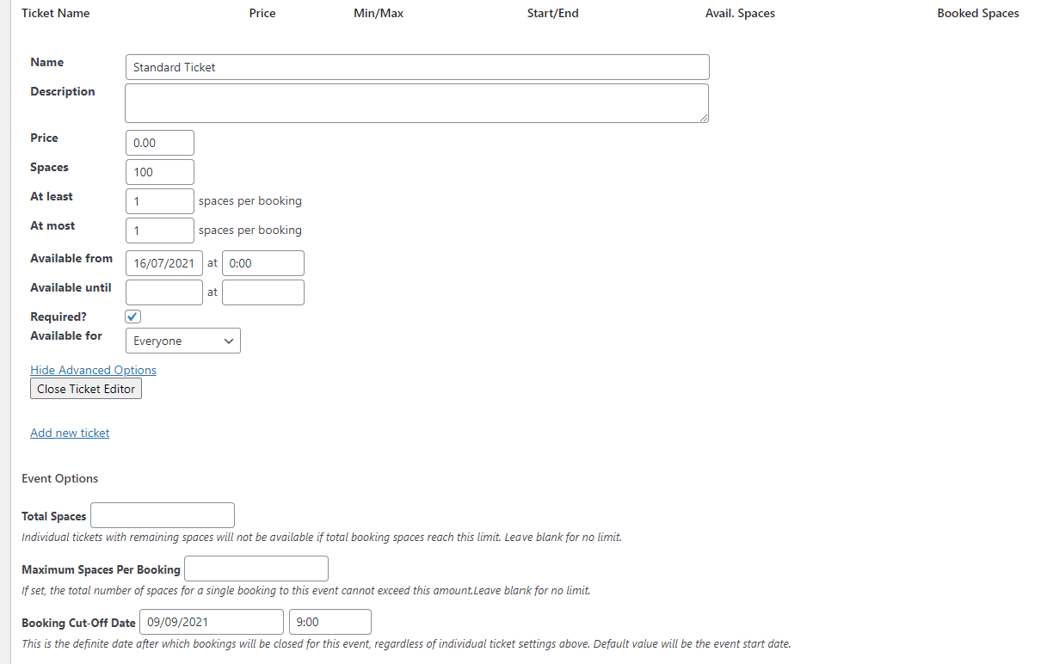

Total Spaces/number of participants: | If selecting a physical room, check the room capacity can accommodate the number of participants you’ve selected above. Note that you should add ‘1’ in the ‘At least’ and ‘At most’ fields, otherwise people can book multiple slots but only one person will be registered (resulting in a lack of data about who is attending).
Available from date/time: | The booking form will become available from this date and time.
Available to date/time: | The date and time when participants will be stopped from being able to make a booking.

Excerpt:

Excerpt – short event description – 30 words maximum. | Paste in the first paragraph from your event description. Aim for 30 words maximum.

Where:

If Physical Location, insert room number: | Select a room from the drop-down menu. If the room you want is not there, please contact the TEL team for a WordPress administrator to add the new room. Please note there is a room called ‘Online event’ and this is only to be used by Nadine (who sets up multiple events ahead of time without a Join Link).
If URL, insert URL and link text e.g. Join Teams meeting | Add a Zoom or Teams meeting link. This will not show on the event’s page (to avoid spam access) but will be included in the iCAL and email confirmation for participants.

PHEAF Reference
PHEAF sessions will continue to be numbered as follows:
- 001-099 - Core Sessions - mandatory for probationers.
- 100-199 - Choice Sessions - mandatory for probationers but can choose which to attend.

For Office Use Only
iTrent Code | CLTPDP/PHEAFXXX-2023-4
Version Number | V4 01.09.2023
Authors

