ROOM: 10W2.47
Lecture Capture Documentation | Using Microsoft Teams or Zoom
It is now possible to schedule lecture capture automatically; which means you do not have to setup recordings for yourself.  Please check here for information:  go.bath.ac.uk/capture  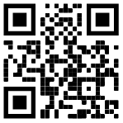 | Microsoft Teams or Zoom can be used for calls and collaborative work from this learning space.  However, only video from one of the cameras and PC desktop sharing to the remote participants is possible.  Unfortunately, it is not possible to share the visualiser or other equipment attached to the lectern inputs to your remote viewers inside a Teams or Zoom call.  Please choose a LUMENS camera in the settings.
Microsoft Teams Settings | Zoom Settings | For Emergency Help
> SETTINGS > DEVICES  Audio:  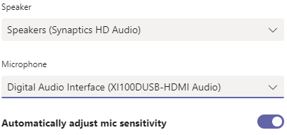Camera:  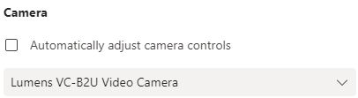 | > SETTINGS > AUDIO  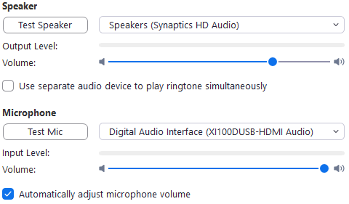  > SETTINGS > VIDEO  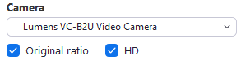 | - CALL SECURITY ON 666 (internal) OR 01225 383999 (mobile)  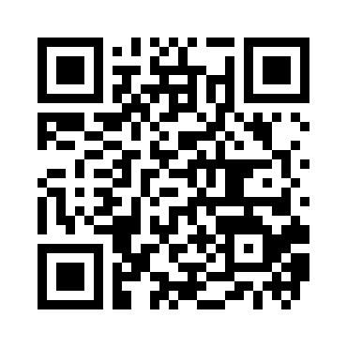  - For urgent technical support please call:  (01225 38) 4846  - FAULT REPORTING:  go.bath.ac.uk/teaching-room-problem

