**LEARNING AND TEACHING HUB**

**DESIGN LIBRARY TEMPLATES FOR CREATING PAGES**

**V1.0 July 2023**

**What is the design library?**

The design library is a group of simple templates to help you build PAGES and ARTICLES in the hub. This document shows the templates for building PAGES only. Please familiarise yourself before creating pages on the site. Additional templates will be added over time – Please check you are viewing the most recent version of this document.

**Related help resources:**

There are short help videos available, including:

* Overview of the new Hub and introduction to pages and articles
* How to create a new page from scratch
* How to create a new article from scratch

If you are creating ARTICLES on the site (rather than general pages) please see the companion document ‘Design library templates for creating ARTICLES’.

**What’s the difference between an article and a page?**

A *page* on the hub is used for general and one-off information. For example, the home page is a page and ‘meet the team’ is a page. Pages can include any combination of text, images, embedded videos, buttons etc.

An *article* is created to provide specific or ‘how to’ step by step guidance, or to answer questions about an individual topic or application. For example, ‘How to create an assessment in Inspera’ is more suited to being an article than a general page. See the related help resources listed above for more information.

In this document you can find all the templates currently available for creating a PAGE.

**Category: Heading and text**

The templates below include a heading and at least one paragraph of text. You can paste text in from existing WordPress pages or word/pdf documents as needed.

**1:**

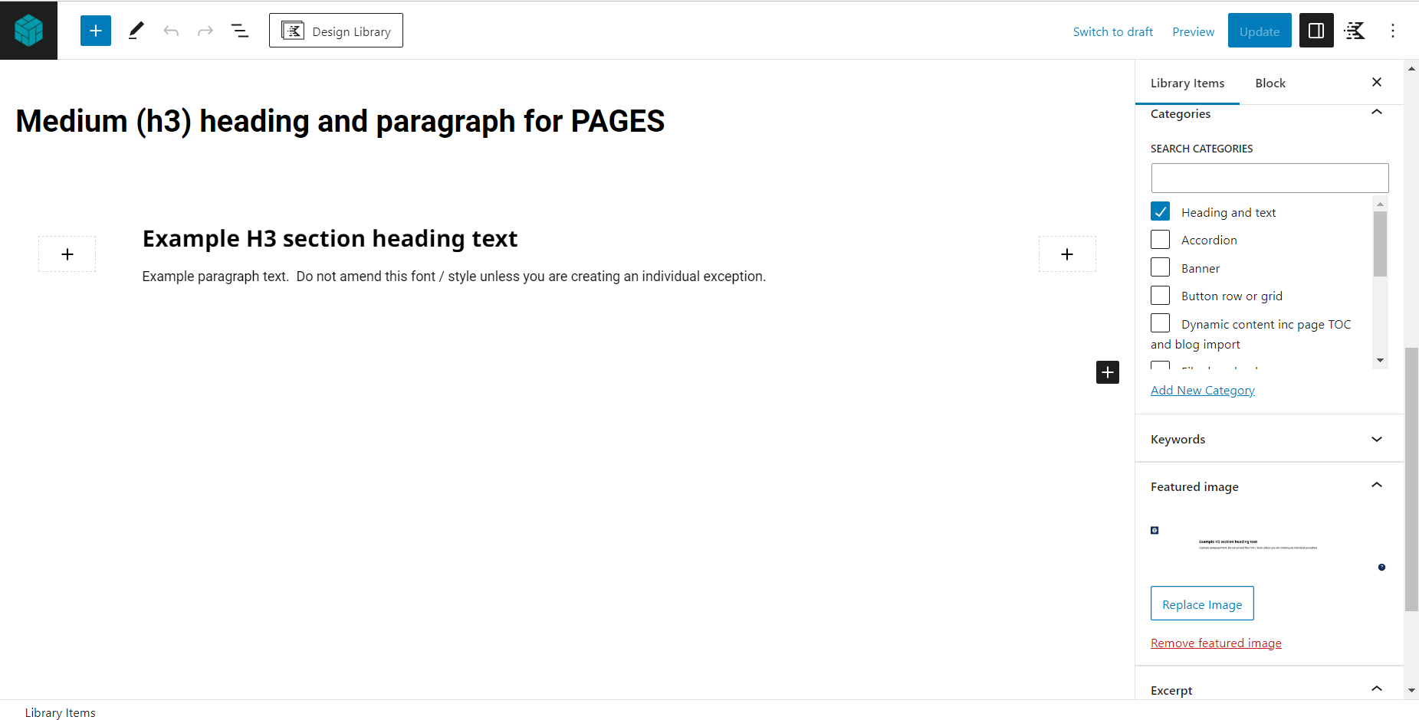

**2:**

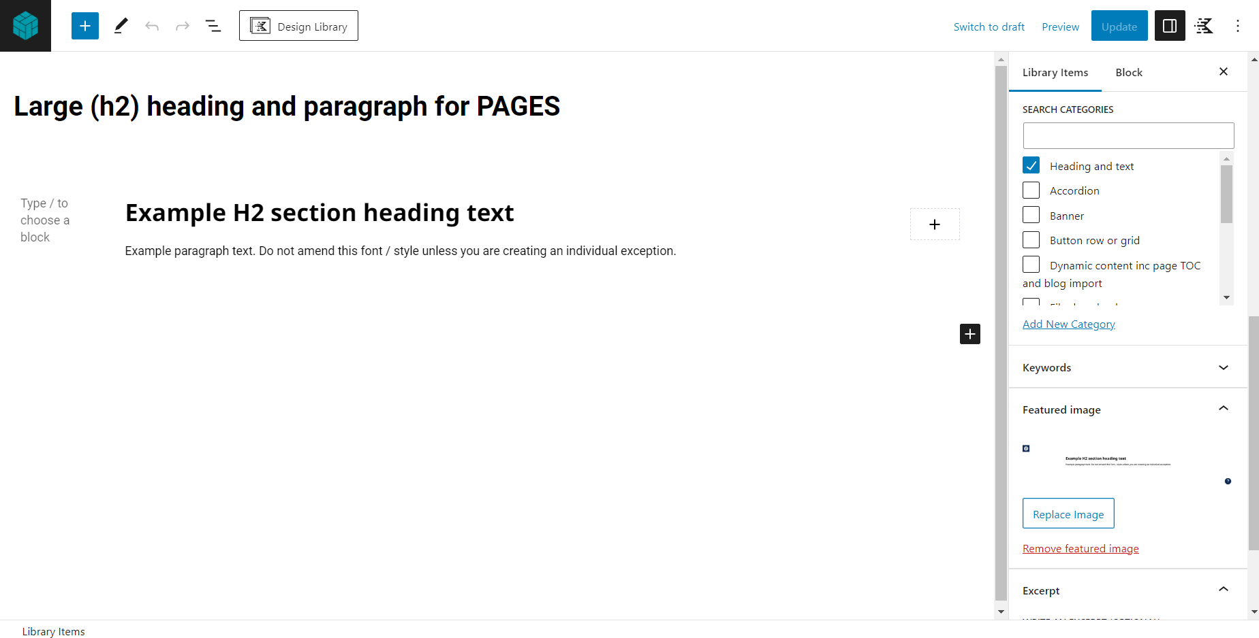

**3:**

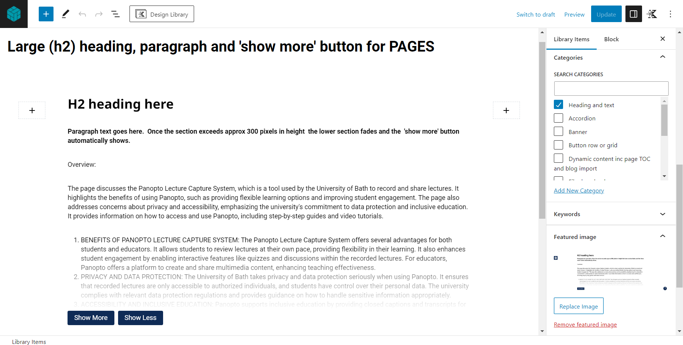

This block includes a ‘show more’ button. It should only be used in the case of a ‘long’ article section being required. Please check if an ACCORDION or TAB template will be more appropriate.

**4:**

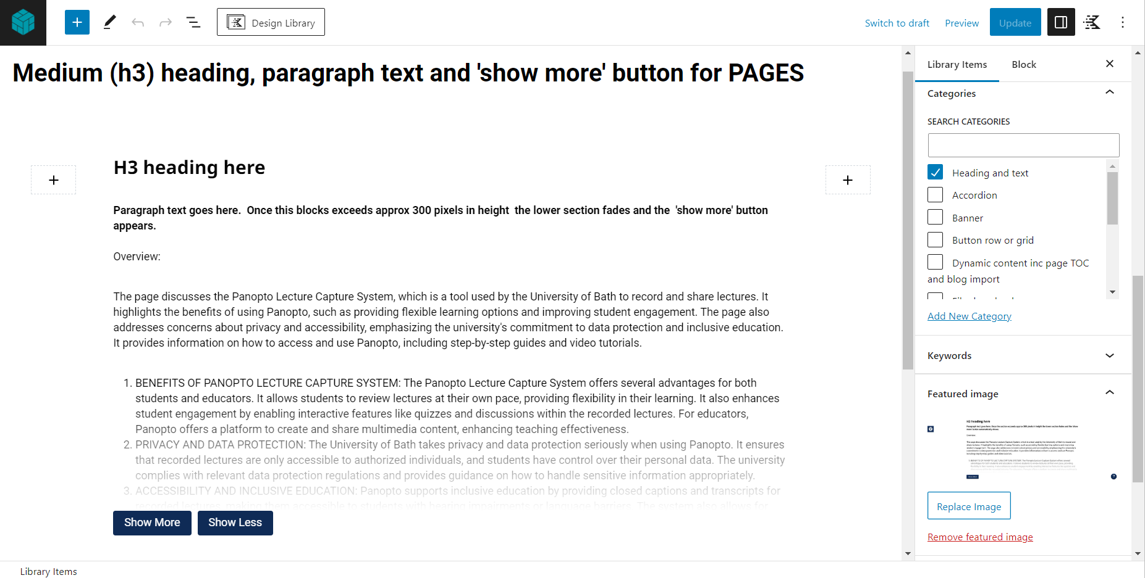

This block includes a ‘show more’ button. It should only be used in the case of a ‘long’ article section being necessary. Please check if an ACCORDION or TAB will be more appropriate.

**Category: Images**

**1:**

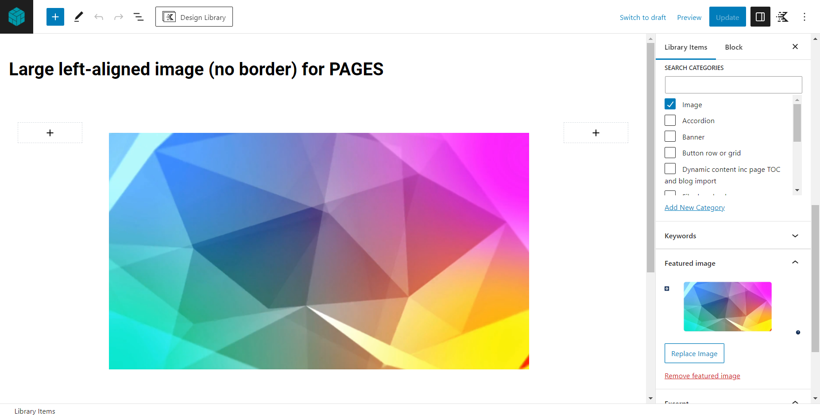

**2:**

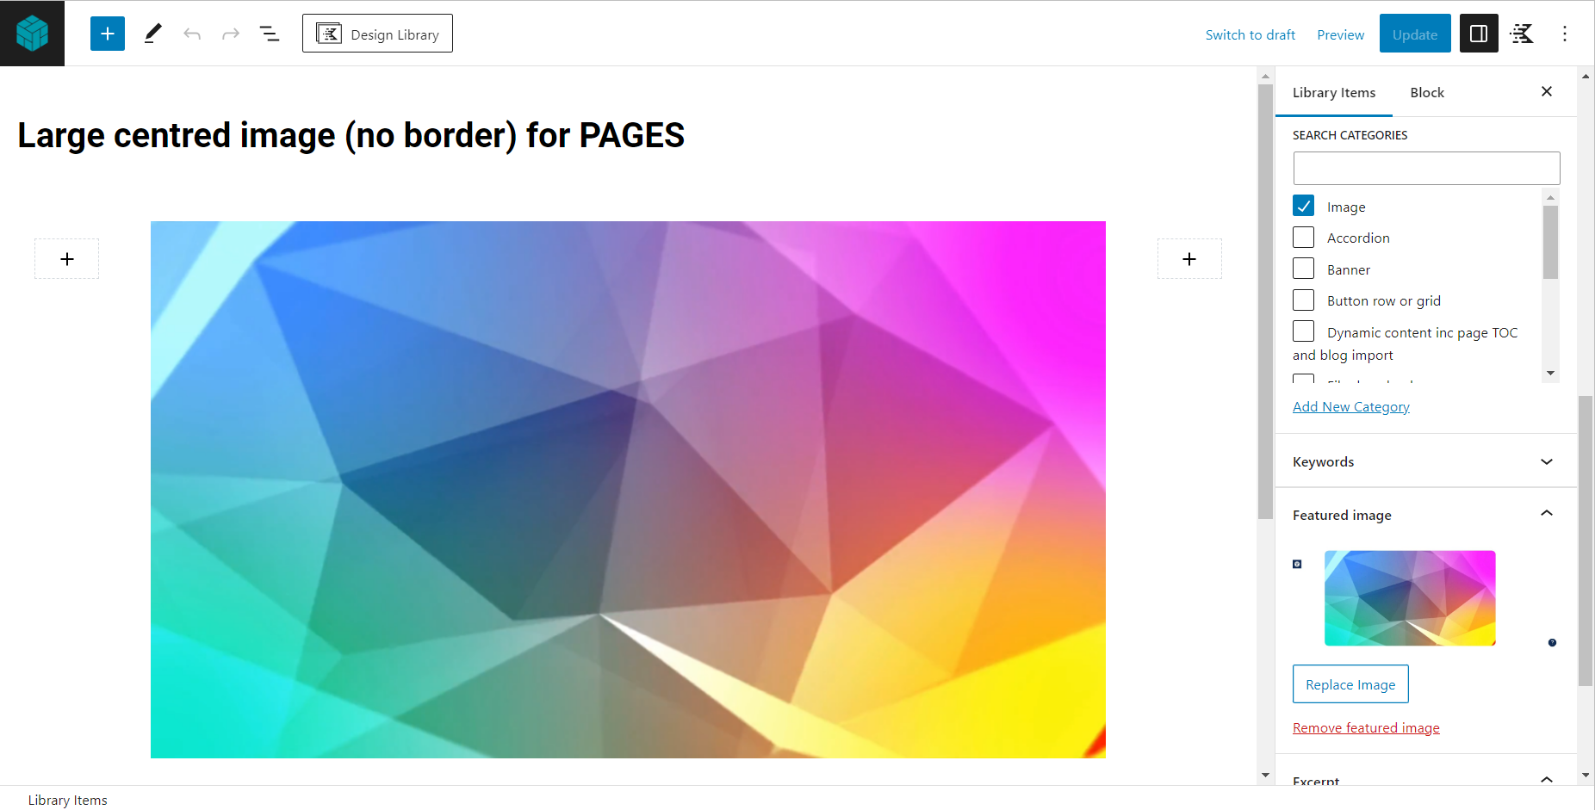

**3:**

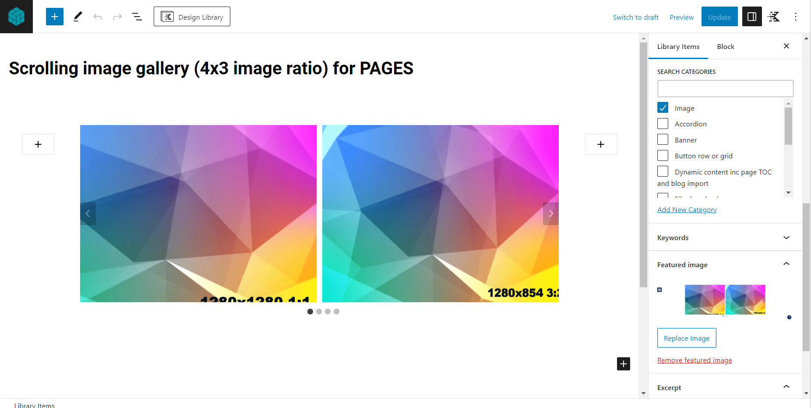

This scrolling gallery can include as many images as needed. The images can be scrolled horizontally by the viewer. Images can be links.

**4:**

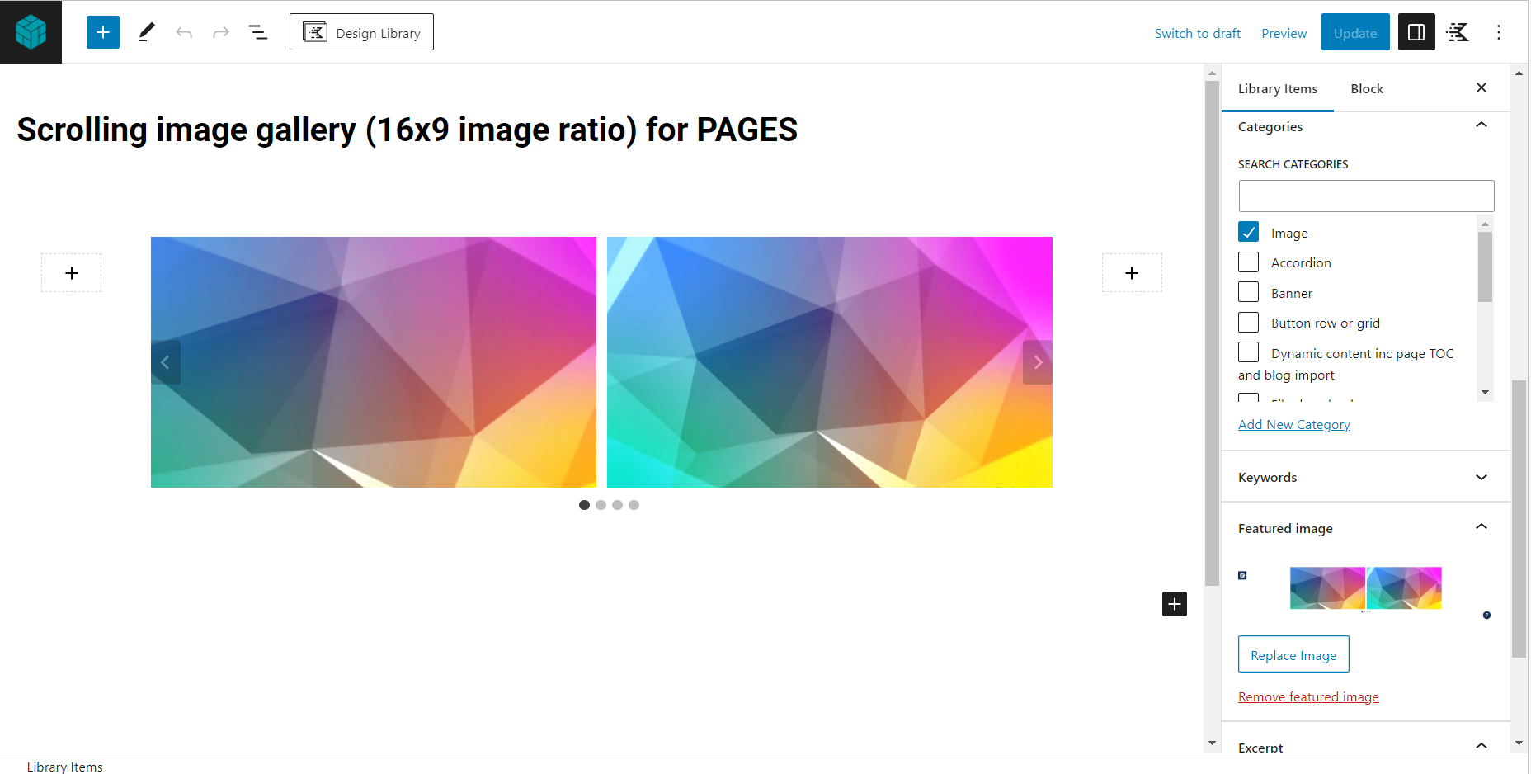

This scrolling gallery can include as many images as needed. The images can be scrolled horizontally by the viewer. Images can be links if required. This gallery is for images best-suited to a 16:9 ratio, including screenshots.

**CATEGORY: Vertical spacer or divider**

**1:**

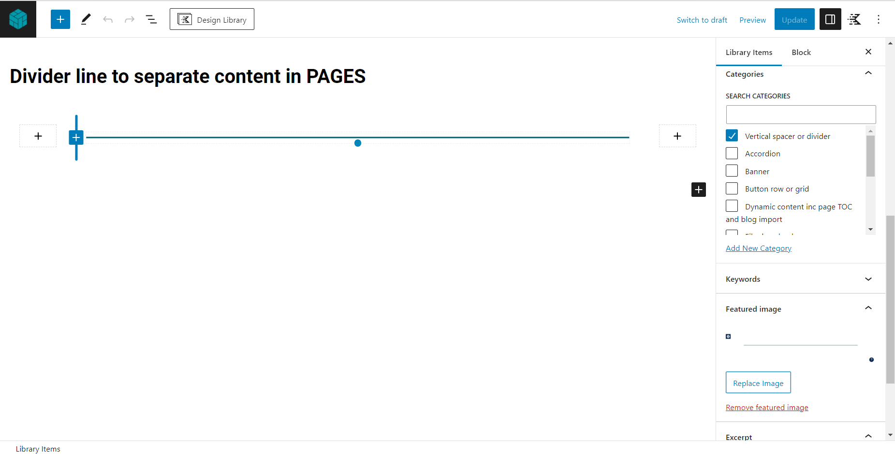

This ‘divider line’ template is used to visually separate content. It will generally be used to separate content when creating a long page.

**Category: Accordion**

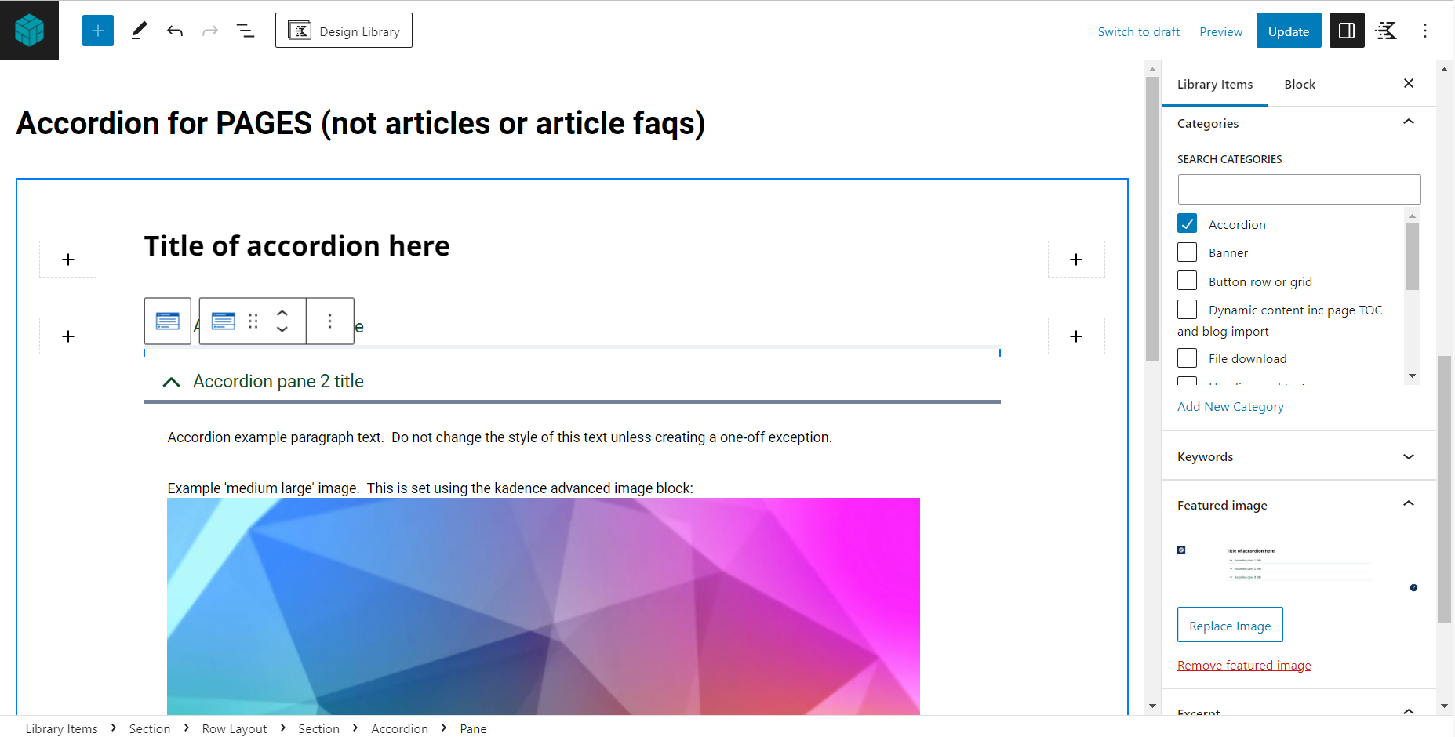

The template includes 3 panes ready to populate with your content. The first pane includes example text and image content to delete or edit as required.

**Category: TABS**

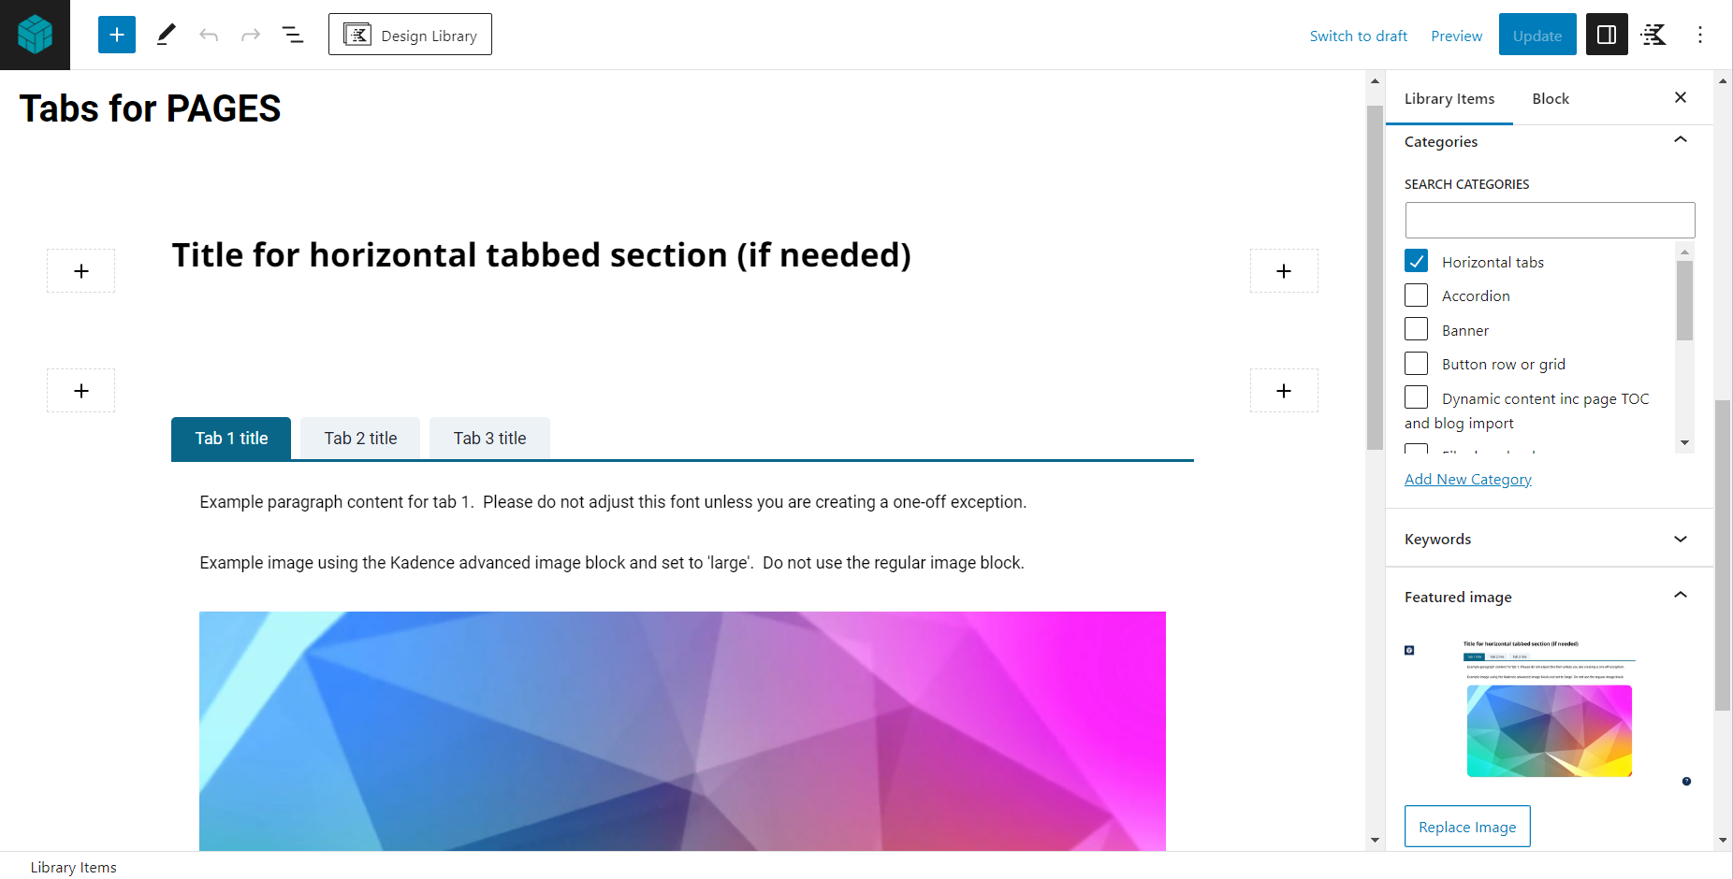

**Category: Video**

**1:**

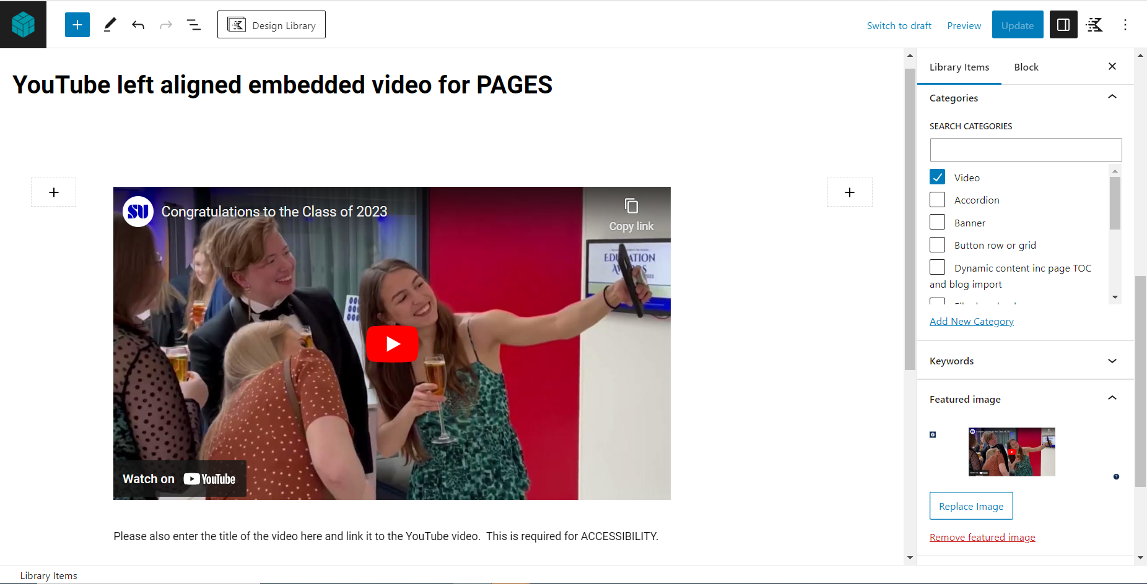

To replace the example YouTube video link click on the video then click the ‘pen’ icon. Please add a manual link to your video below the preview where indicated – This is required for accessibility.

**2: Re:View video**

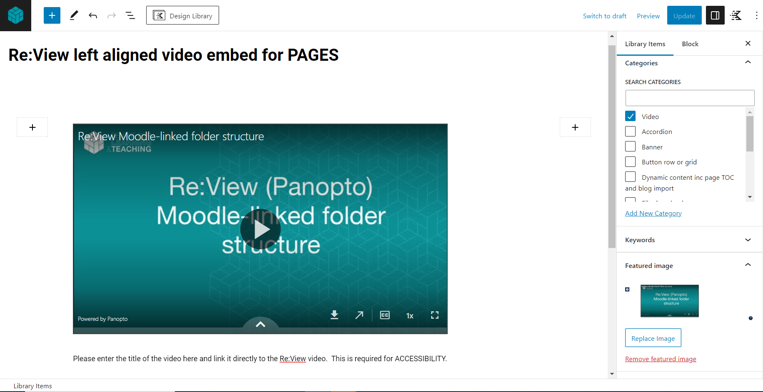

This template uses custom html. If you are embedding Re:View videos for the first time and experience issues please seek advice.

**Category: Note box for warnings and advisories**

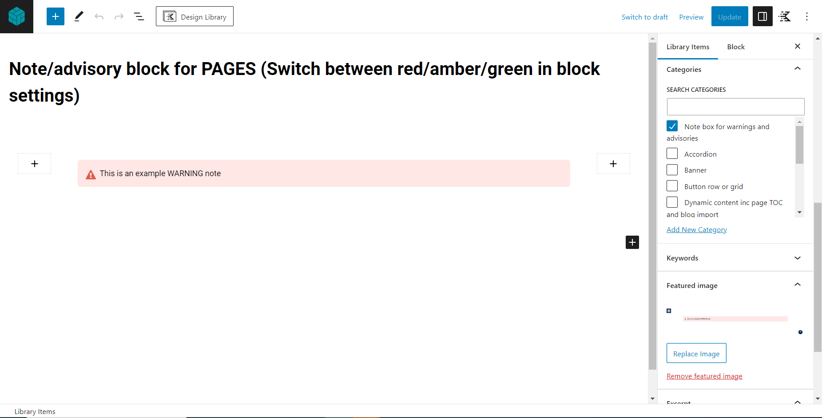

Use this template to add a coloured note box to a page. Use the block settings panel on the right to switch between a red, amber or green note as appropriate. Red notes should be used for warnings, amber for non-critical advisories and green for ‘help’ or ‘tips’.

**Category: File download**

