**LEARNING AND TEACHING HUB**

**DESIGN LIBRARY TEMPLATES FOR CREATING ARTICLES**

**V1.0 July 2023**

**What is the design library?**

The design library is a library of simple templates to help you create PAGES and ARTICLES for the hub. This document relates to ARTICLES only. Please familiarise yourself with the templates shown before creating articles on the site.

**Related help resources:**

There are short help videos available including:

* Overview of the new Hub and introduction to pages and articles
* How to create a new page from scratch
* How to create a new article from scratch

If you are creating ARTICLES on the site (rather than general pages) please see the companion document ‘Design library templates for creating PAGES’.

**What’s the difference between an article and a page?**

A *page* on the hub is used for general, mixed and one-off information. For example, the home page is a page and ‘meet the team’ is a page. Pages can include any combination of text, images, embedded videos, buttons etc.

An *article* is used to provide specific or ‘how to’ step by step guidance, or to answer questions about an individual topic or application. For example, ‘How to create an assessment in Inspera’ is best suited to an article rather than a general page. See the related help resources listed above for more information.

In this document you can find all the templates available for creating an ARTICLE.

**Category: Heading and text**

The templates below include a heading and at least one paragraph of text. You can paste in text from your existing pages or Word/Pdf documents as needed.

**1:**

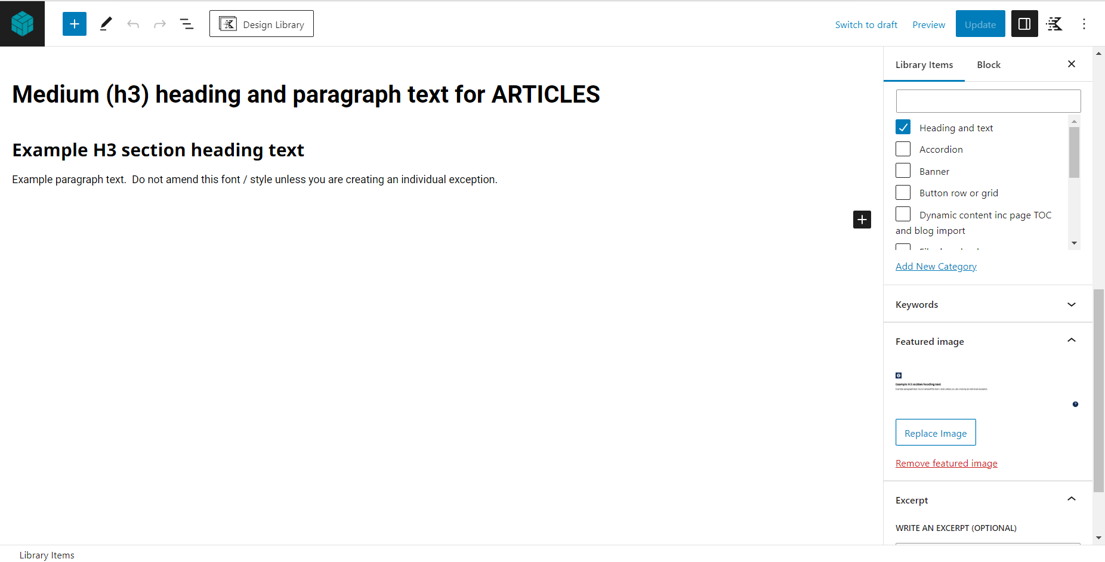

**2:**

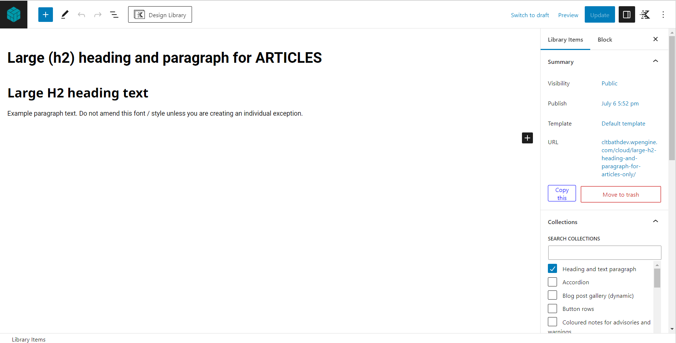

**3:**

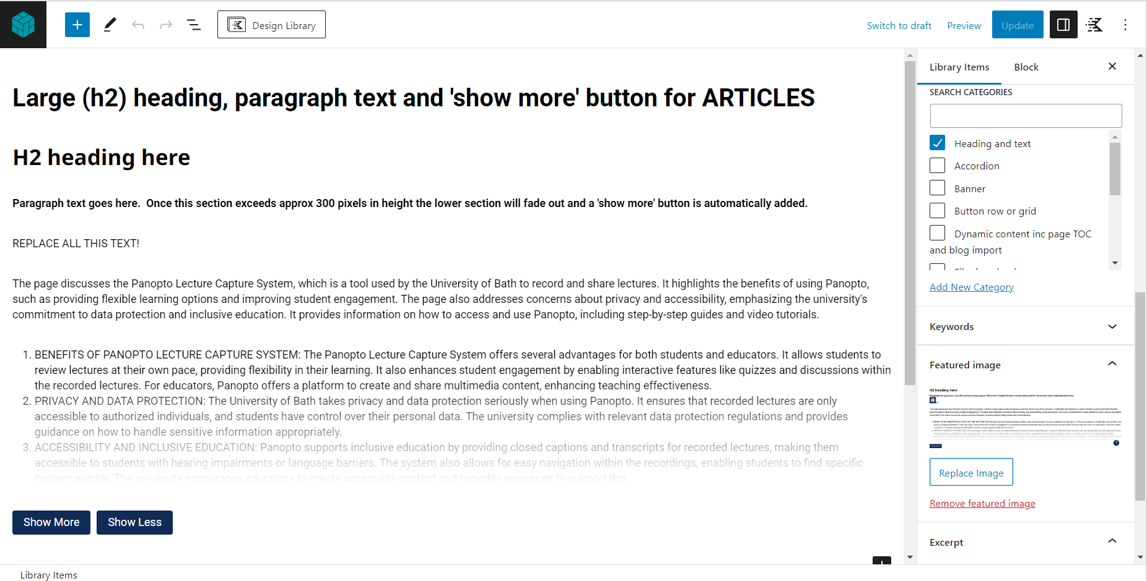

This block includes a ‘show more’ button. It should only be used if a ‘long’ article section is necessary. Please check if an ACCORDION or TABS will be more appropriate.

**4:**

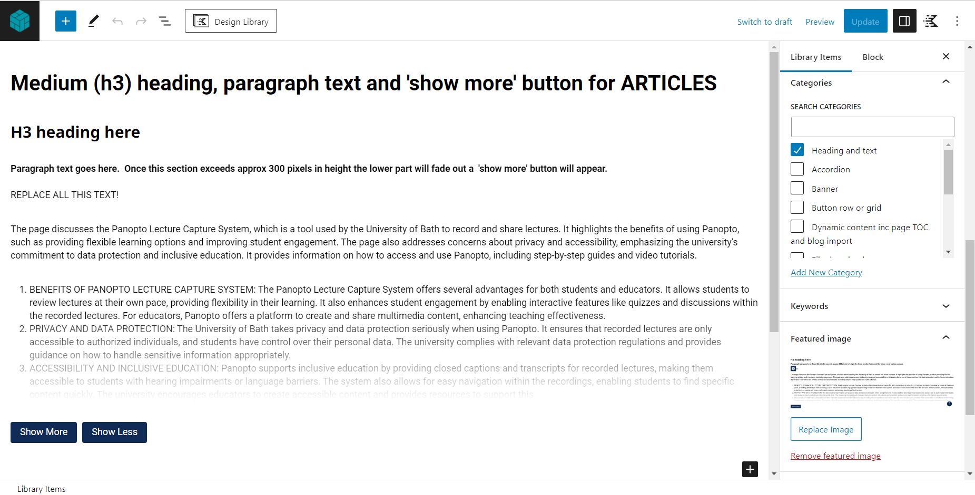

This block includes a ‘show more’ button. It should only be used if a ‘long’ article section is necessary. Please check if an ACCORDION or TABS will be more appropriate.

**Category: Images**

Use these blocks when a single image is needed. To replace the example ‘rainbow’ image, select it then click REPLACE. You can upload an image directly from your computer or re-use an image already in the WordPress media library.

**1:**

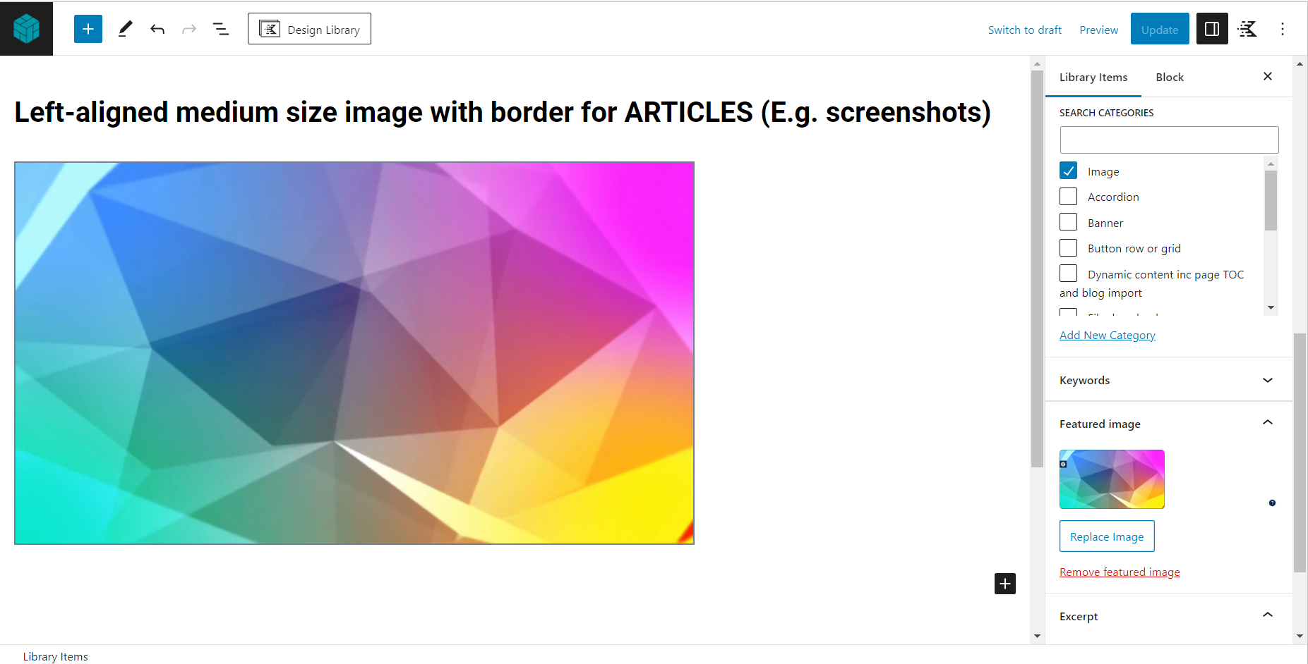

**2:**

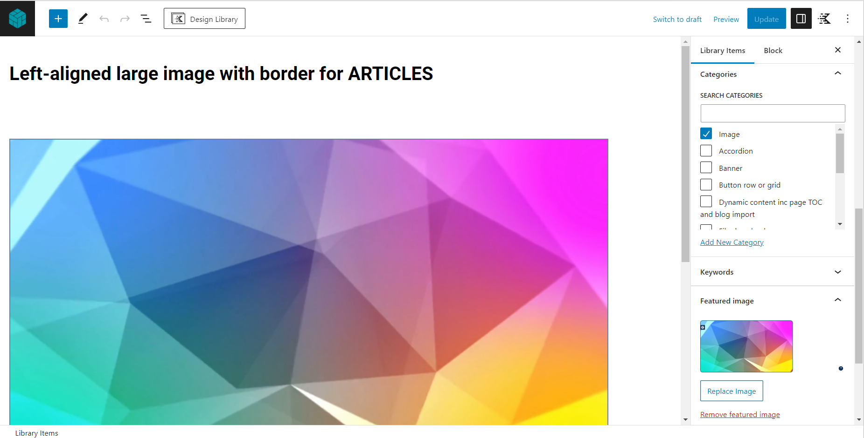

**CATEGORY: Divider line and spacer**

**1:**

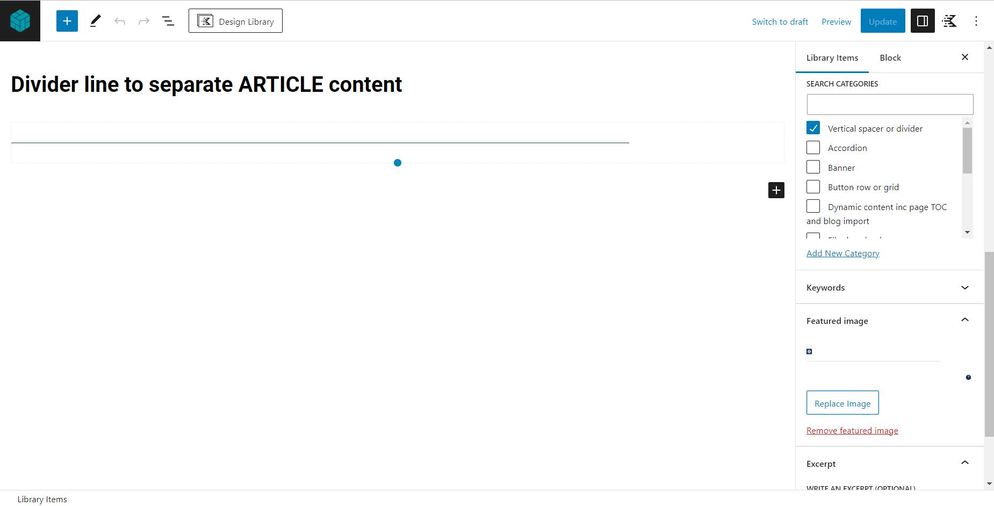

The ‘divider line’ template is used to visually separate article content. It will generally be used when adding a long article.

**2:**

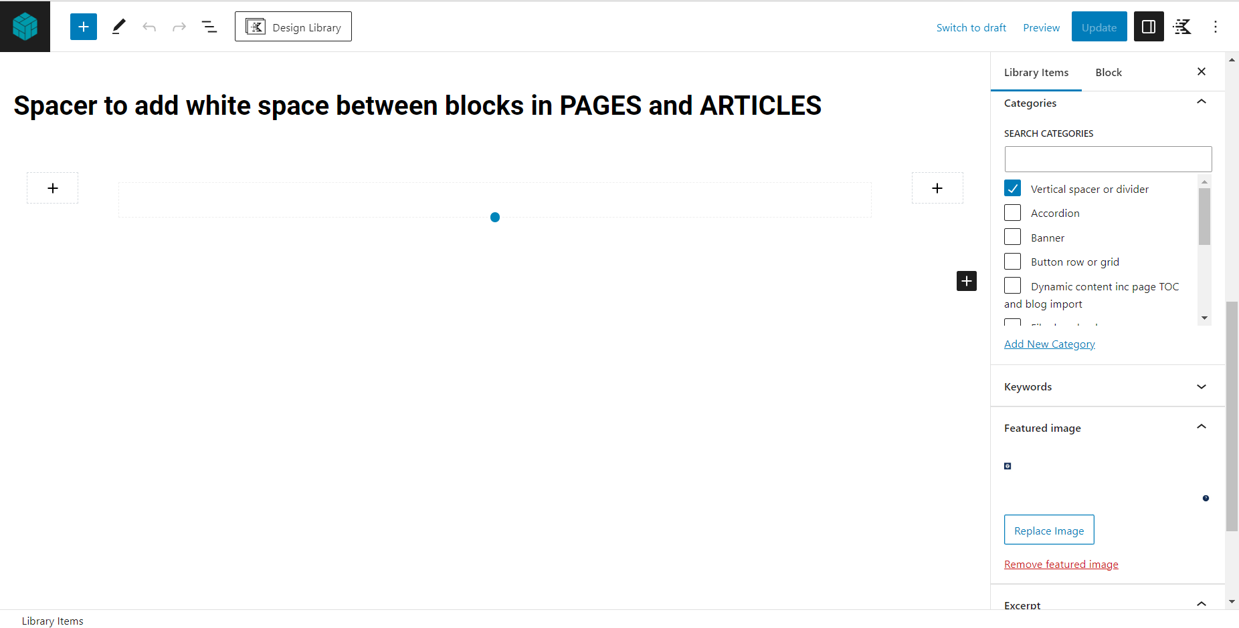

The spacer is an ‘invisible’ block to add white space if your content looks ‘bunched up’. Drag the circular handle upwards to decrease the height of the spacer or downwards to increase it.

**Category: Accordion**

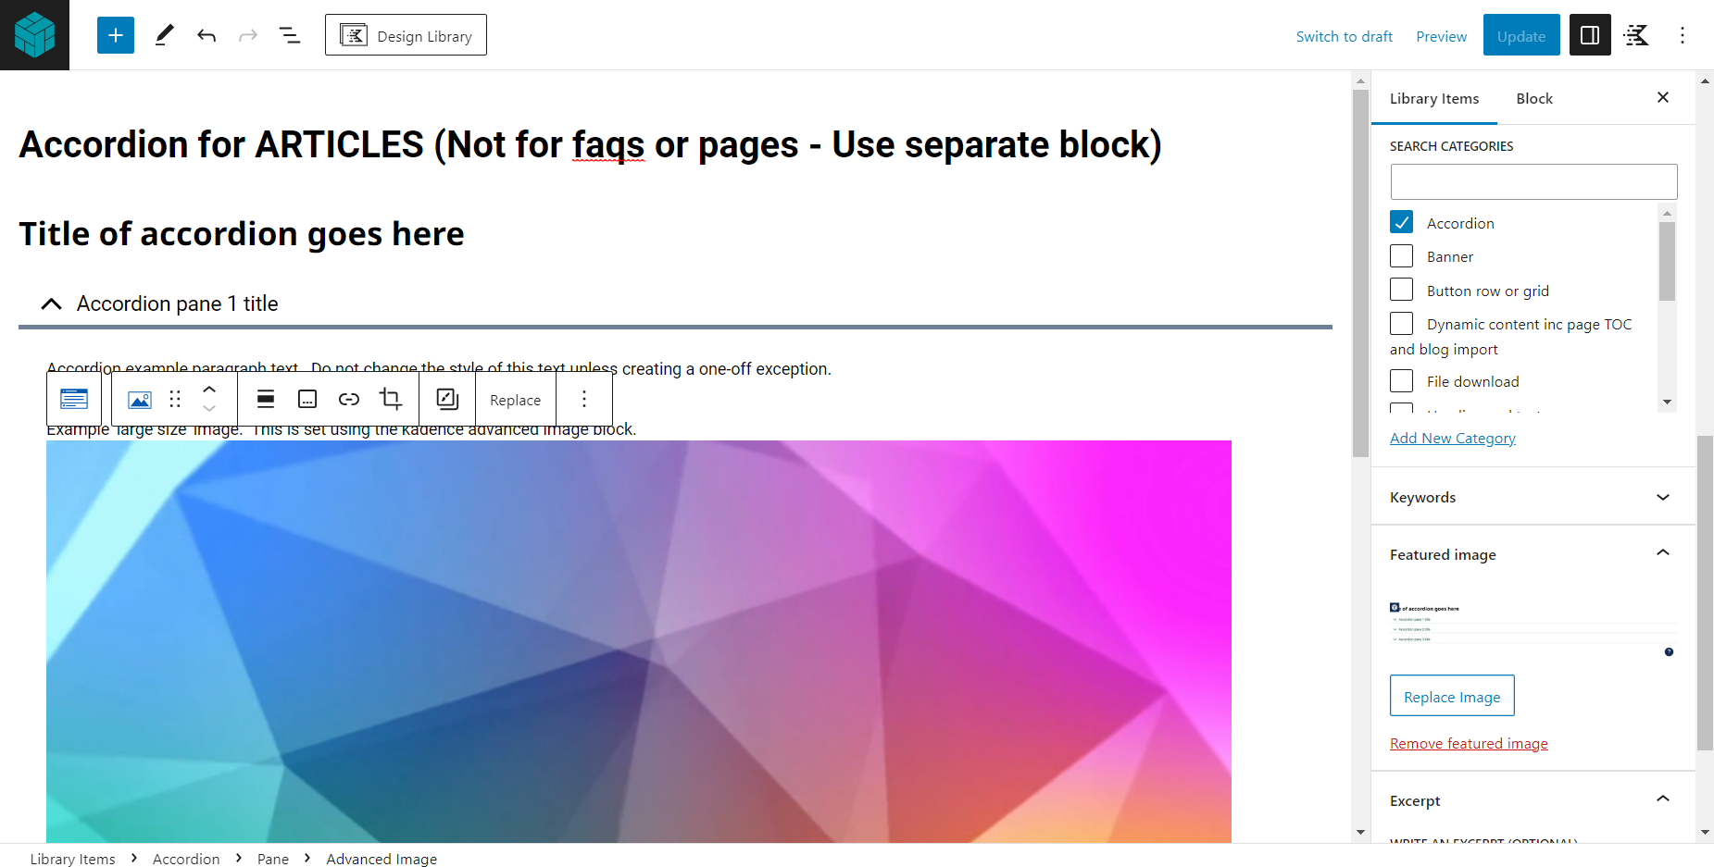

This block includes a heading above the accordion – Delete if not needed.

The template includes 3 panes ready to populate with your content. The first pane includes example text and image content to delete or edit as required.

**Category: TABS**

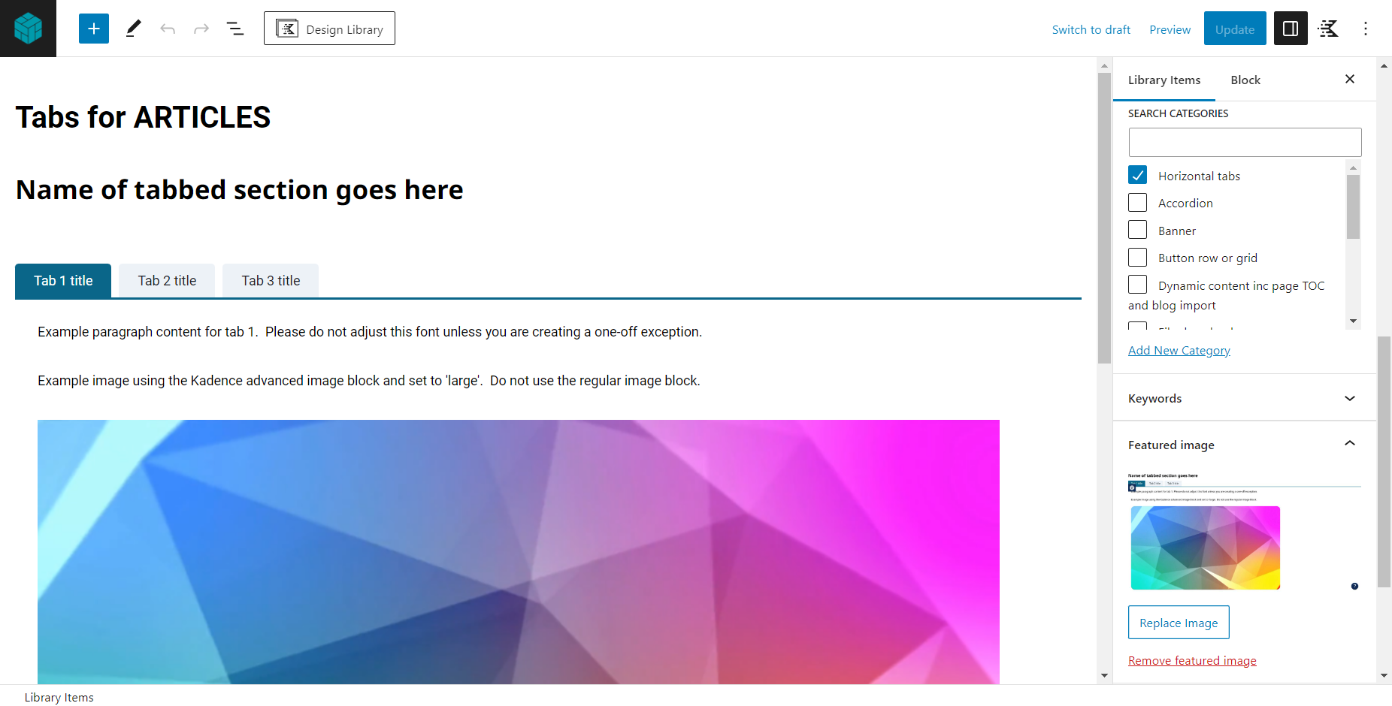

The template includes 3 tabs ready to populate with your content. The first tab includes example text and image content to delete or edit as needed. Tabs can be added or deleted as needed. If you require more than five tabs consider if there may be a better way to display your information (E.g. Accordion).

**Category: Video**

Select the appropriate block based on whether you are embedding a youtube video or an internal re:view video.

**1:**

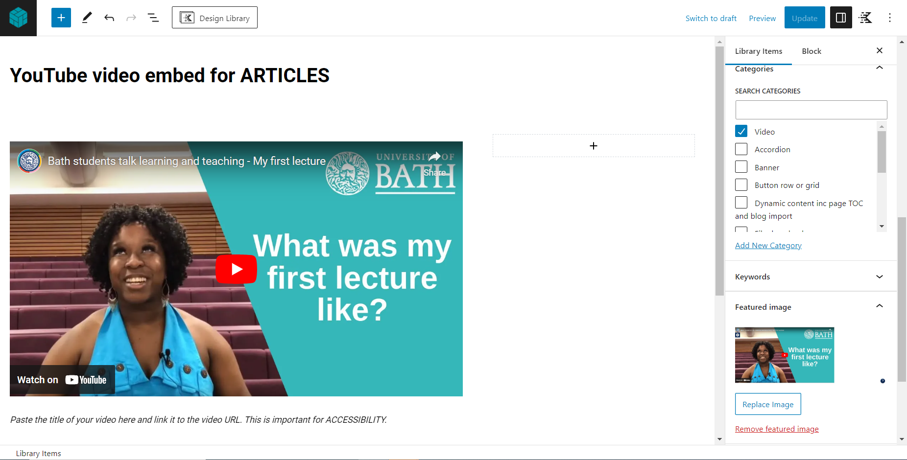

To replace the example YouTube video link click on the video then click the ‘pen’ icon. You can then paste the required URL. Please add a manual link to the video below the preview where indicated – This is required for accessibility.

**2:**

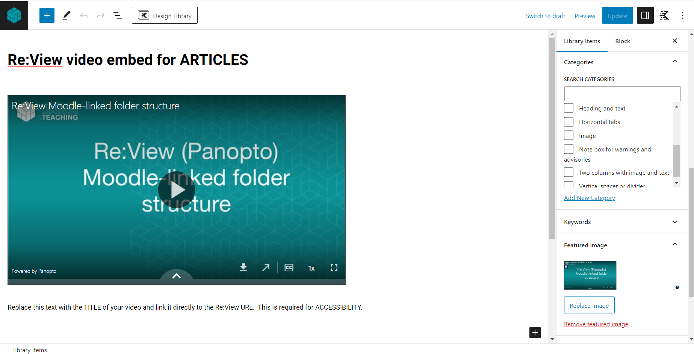

This template uses custom html. If you are embedding Re:View videos for the first time and are unable to view the embedded video please seek help.

**Category: Note box for warnings and advisories**

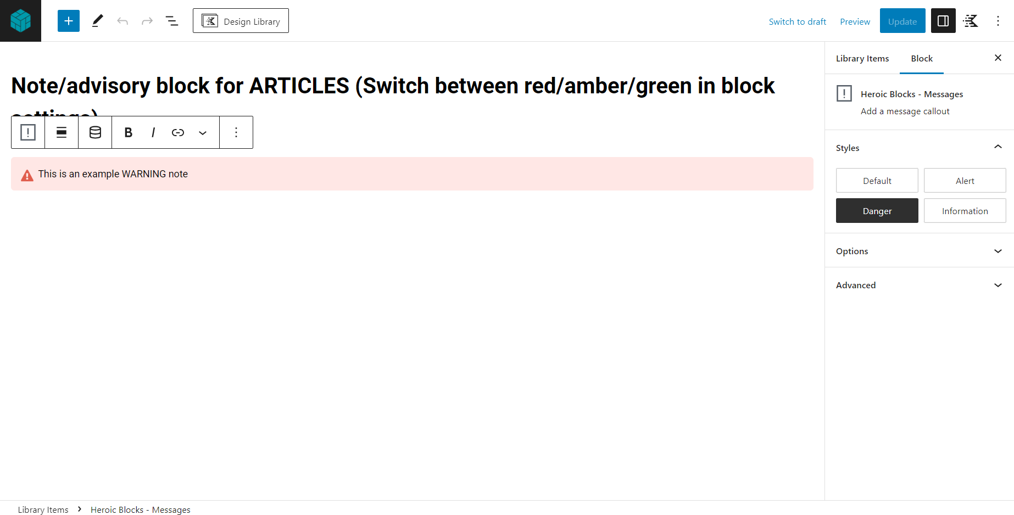

Use this template to add a simple coloured note box to an article. Use the block settings panel on the right (as shown) to switch between a red, amber or green note as appropriate. Red notes should be use for warnings, amber for non-critical advisories and green for extra ‘help’ or ‘tips’.

**Category: File download**

